Using and controlling reactions - prac test

1. a) Draw energy profile diagrams of
i) an exothermic reaction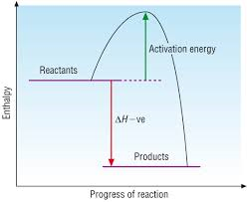
ii) an endothermic reaction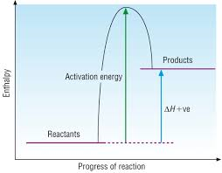
b) Clearly label ΔH and the activation energy on your diagrams
c) explain why heat is needed initially for both types of reaction
d) draw two energy profile diagrams to show the action of a catalyst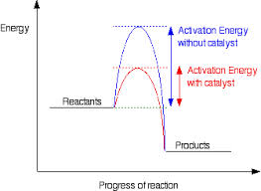

2. Ammonia is produced commercially via the Haber process
N₂ + 3H₂ → 2NH₃ ΔH = -92.4 kJ mol⁻¹
- state the features of a reaction at equilibrium
Constant concentration, pressure, heat, colour etc

- name two experimental conditions that will increase the rate of reaction and using collision theory explain why these conditions lead to an increased rate
Heat – increases energy of molecules, so increases the number of collisions and the number of successful collisions
Pressure – effectively increases the concentration of all reactants, increases the number of collisions
- use Le Chateliers principle to explain the effect of pressure on the yield of ammonia
High pressure will favour the direction that reduces the total number of molecules. This will favour the products side as it has fewer molecules (2 vs 4).
- Describe the effect on the yield and reaction rate by the use of a catalyst
Catalyst will not affect the yield. Catalysts reduce the activation energy, which will increase the rate of reaction.
- If the reaction has a Kc value of 0.3, does the reaction have a greater proportion of reactants or products?
Kc < 1 indicates a greater proportion of reactants. 0.3 will have a greater proportion of reactants than products.
f) Fill in the following table for this reaction (at a different temperature than (e))
 | N₂ | H₂ | NH₃
Mole Ratio | 1 | 3 | 2
Initial (mol) | 1.0 | 2.0 | 0.0
Change (mol) | 0.5 | 1.5 | 1.0
Equilibrium (mol) | 0.5 | 0.5 | 1.0

- If the reaction was done in a 10.0L reaction vessel calculate the concentrations of reactants at equilibrium
N₂ – 0.5 / 10 = 0.05 molL⁻¹
H₂ – 0.5 / 10 = 0.05 molL⁻¹
NH₃ – 1 / 10 = 0.1 molL⁻¹
- calculate Kc for this reaction
(0.1)² = 1600
(0.05) (0.05)³

iii) if equilibrium was established after 10 mins, draw a graph of concentration versus time for 15 mins of H₂, N₂ and NH₃ on the same graph.

3. a) What methods of reduction are used to separate aluminium, iron and copper from their ores?
Al – electrolysis
Fe – smelting
Cu - roasting
b) Explain why coppers method of reduction cannot be used for aluminium and why aluminium’s method of reduction is not used for copper
Aluminium is too reactive to be reduced by roasting, a stronger method of reduction is required. Electrolysis will work for copper but is not required and as it is much more expensive a cheaper method will be used.

4. Describe the difference between a galvanic cell and a fuel cell
A fuel cell is a special type of a galvanic cell that has constant supply of reactants and constant removal of products.

5. Draw a diagram of a galvanic cell using electrode/electrolyte combinations of Zn/Zn²⁺ and Cu/Cu²⁺
a) clearly label the anode, cathode and direction of electron flow on your diagram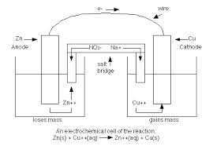
b) Show the direction of positive and negative ions on the salt bridge
c) write half equations that occur at the two electrodes and hence the overall reaction
Zn -> Zn²⁺ + 2e⁻
Cu²⁺ + 2e⁻ -> Cu
Zn + Cu²⁺ -> Zn²⁺ + Cu

6. Galvanic cells can also be constructed using inert electrodes. For the following reaction graphite electrodes are used. This reaction involves conversion of Cr₂O₇²⁻ to Cr³⁺ and I⁻ to I₂
a) Write balanced half equations for the two reactions, and hence the overall reaction
Cr₂O₇²⁻ 14H⁺ 6e⁻ -> 2Cr³⁺ + 7H₂O
2I⁻ -> I₂ + 2e⁻
Cr₂O₇²⁻ 14H⁺ + 6I⁻ -> 2Cr³⁺ + 7H₂O + 3I₂
b) Using oxidation numbers identify which reaction is reduction and which is oxidation
2xCr + 7x-2 = -2 I₂ -1 -> 0
2Cr – 14 = -2 therefore oxidation
2Cr = +12
Cr = +6
+6 -> +3 therefore reduction
c) Hence assign each reaction as the anode or cathode
Iodine at the anode
Chromium at the cathode

7. a) If the enthalpy of combustion of butanol is 1.3 MJ mol⁻¹, calculate the energy per gram in kJ g⁻¹
1.3 MJ mol⁻¹ / (12.01 x 4 + 1.008 x 10 + 16) = 0.0175 MJ g⁻¹
17.5 kJ g⁻¹
b) write a balanced thermochemical equation for the complete combustion of butanol
C₄H₁₀O_{(l)} + 6O_{2(g)} -> 4CO_{2(g)} + 5H₂O_{(g)} ΔH = -1.3 MJ mol-1
c) how much energy would be released if 3 mol of butanol was burned?
3 x 1.3 = 3.9 MJ
d) 1g of butanol was dissolved in 100 ml of water, raising the temperature of the water by 2⁰, calculate the energy released.
4.2 x 100 x 2 = 840 J
e) By how much would the temperature increase is the 1g of butanol had been burned rather than dissolved to heat the water?
1g of butanol releases 17.5 kJ
17500 = 4.2 x 100 x T
T = 41.7°

8. Consider the following hydrogen / oxygen galvanic cell
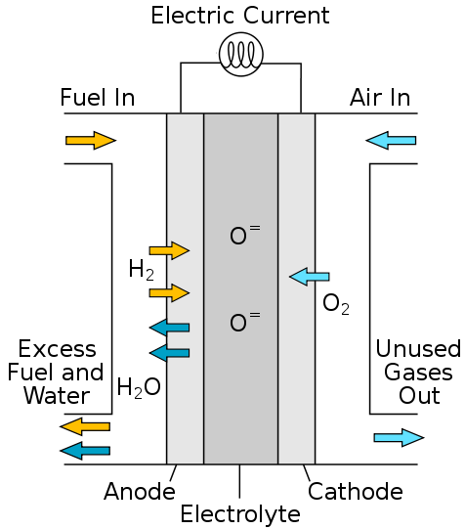
- Use half equations to determine the overall reaction for this galvanic cell
H₂ + O²⁻ -> H₂O + 2e⁻
O₂ + 4e⁻ -> 2O²⁻
2H₂ + O₂ -> 2H₂O
b) Can this cell be classified as a fuel cell?
Yes. The fuel is constantly being imported and the products are being removed.

9. What are the pros and cons of fossil fuel use for energy
Pro
Easy to use and transport
Good supply

Cons
Pollution
Non renewable

10. Zinc is produced via 4 main steps.
a) List the 4 main steps in the production of zinc, include equations and the reasons for each step
- Concentration
Removes unwanted waste material
Process is froth floatation
- Conversion
ZnS is converted to ZnO and then ZnSO4
2ZnS_{(s)} + 3O_{2(g)} -> 2ZnO_{(s)} + 2SO_{2(g)}
ZnO_{(s)} + H₂SO_{4(aq)} -> 2ZnSO_{4(aq)} + H₂O_{(l)}
ZnSO4 is highly soluble in water so can form aqueous solution
- Purification
Zn powder added to remove less active metals that would be reduced in preference to zinc in the next step. Zinc is more reactive than these ions and hence will displace the less active metal ions. Eg:
Zn_{(s)} + 2Ag⁺_{(aq)} -> 2Ag_{(s)} + Zn²⁺_{(aq)}

- Electrolysis
Electrolytic cell to reduce zinc ions to zinc metal
Cathode Zn²⁺_{(aq)} + 2e⁻ -> Zn_{(s)}
Anode 2H₂O_{(l)} -> O_{2(g)} + 4H⁺_{(aq)} +4e⁻
Overall 2Zn²⁺_{(aq)} + 2H₂O_{(l)} -> 2Zn_{(s)} + O_{2(g)} + 4H⁺_{(aq)}
b) What metals will not be removed by the addition of zinc powder?
Any metals that are more reactive than zinc will not be removed by this process.
- Why is an aqueous solution preferred to a molten solution in the production of zinc?
Dissolving zinc in an aqueous solution requires significantly less energy than keeping the solution molten for the duration of the electrolysis process. Less energy means lower costs.
d) Why is an aqueous solution not used in the production of magnesium?
For more active metals such as magnesium, water will be reduced in preference to the magnesium at the cathode. You would produce hydrogen gas rather than magnesium metal.

