STAGE 2 CHEMISTRY

READING

The Essentials book pg 62-63

Elemental and Environmental Chemistry

Unit 9

Water Treatment:

describe how flocculation works,

state how bacteria are killed by chlorine, hypochlorous acid and hypochlorite ions,
explain how the equilibrium between Cl₂ and H₂O and HOCl and HCl is affected by pH.

The Syllabus statement says:

Key Ideas | Intended Student Learning
Suspended mater is removed from water by flocculation followed by sedimentation or filtration. | Describe the use of aluminium ions in the removal of suspended matter from water.
Hypochlorous acid, chlorine, and hypochlorites are used for water purification. | State that hypochlorous acid, chlorine, and hypochlorites kill bacteria by their oxidising action.
Chlorine is used for water purification. | Explain the effect of pH on the equilibrium between chlorine, water, and hydrochloric acid and hypochlorous acid.

The KEY IDEAS here are:

- Flocculation and Water Filtration
During the process known as flocculation, salts containing highly charged cations (such as Al³⁺ ions) are added to the water. The suspended particles in the water have a negative charge on their surface and will be attracted to these cations. This creates larger sized particles, which can no longer stay in solution and hence settle to the bottom. These can then be removed by sedimentation or filtration.

- Water Purification
In order to kill bacteria and make water suitable for drinking, it must be treated with an oxidising agent such as chlorine gas Cl₂ or hypochlorite ions OCl⁻

- chlorine and hypochlorite ions can react with water to form hypochlorous acid:

Cl₂ + 2H₂O HOCl + H₃O⁺ + Cl⁻ [This solution is acidic] Equation 1

OCl⁻ + H₂O HOCl + OH⁻ [This solution is basic] Equation 2

2 hypochlorous acid, chlorine and hypochlorite ions kill bacteria by their oxidising action. They
enter the cells of bacteria and oxidise vital enzymes that prevent the growth of the bacteria.

3 the amount of hypochlorous acid can be altered by changing the pH of the solution.
For Equation 1: raising the pH (add a base) will increase the amount of HOCl
For Equation 2: lowering the pH (add an acid) will increase the amount of HOCl

pH levels must be monitored regularly and adjusted to produce the correct levels of
hypochlorous acid in the water.
What makes water drinkable?

It must be free of toxic chemicals, disease carrying bacteria and have no undesirable odours, tastes or colours.

The following notes describe how water can be made to look clean and be bacteria free.

Water Treatment - Flocculation

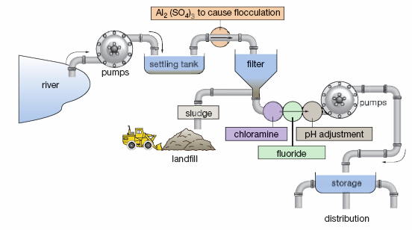

The figure above shows how some cities treat the water before it is used for human consumption.

The process of flocculation (and coagulation) is used to help remove fine suspended solids and colloidal particles. Colloidal solids are particles with a diameter of less than 0.01 mm. These include fine silts or clays, bacteria and viruses that might not settle for days, months or even years. These substances make the water
appear cloudy or turbid. Flocculation involves using a chemical coagulant that will combine smaller particles into larger ones. The larger particles can be filtered out more readily.

In the coagulation process, a coagulant such as aluminium sulfate, Al₂(SO₄) ₃ (sometimes called alum), is added to the water and stirred. The alum reacts rapidly with the carbonates, bicarbonates and hydroxides present in the water. This reaction produces a gelatinous (jelly-like) precipitate of aluminium hydroxide that entraps and absorbs impurities. The clump of particles is called a ‘floc’.

After 20 to 30 minutes, the floc particles are usually visible and will look like tiny tufts of cotton wool, separated by clear water. The water is then filtered to remove these particles. Generally, the water is filtered through sand that traps the undissolved particles.

These processes are very effective at removing fine suspended particles that attract and hold bacteria and viruses to their surface. Research has shown that these processes alone are capable of removing up to 99.9% of the bacteria and 99% of the viruses from water supplies.

Some of the organic matter washed from soil and vegetation as water travels into the drinking water source is also removed. This natural organic matter is often responsible for any brown discolouration in water.
Natural organic matter that is not removed may contribute to the taste and odours present in some drinking water.

Water Treatment – Purification

In order to kill bacteria not removed by flocculation, and make water suitable for drinking, it must be treated with an oxidising agent.

Two common oxidising agents used for this process are chlorine gas (Cl₂) and hypochlorite ions (OCl⁻).

When added to water, chlorine and hypochlorite ions will react and form hypochlorous acid (HOCl).

Equ 1 Cl₂ + 2H₂O where the resulting solution is

Equ 2 OCl⁻ + H₂O where the resulting solution is

Hypochlorous acid, chlorine and hypochlorite ions kill bacteria by their oxidising action.

When they act as oxidising agents, all three are reduced to the chloride ion.

Write the half equation for the reduction of chlorine:

It is this oxidising action that makes them good for water purification.

Of the three, hypochlorous acid is the most powerful oxidising agent and is hence most effective at oxidising the bacteria.

Both species, OCl– and HOCl, kill micro-organisms by attacking the lipids (fats) in the cell walls and destroying the enzymes and structures inside the cell through oxidation. The difference between HOCl and OCl– is the speed at which they oxidise other chemicals. Hypochlorous acid is able to oxidise biological compounds
in several seconds, whereas the hypochlorite ion may take up to 30 minutes. The major reason is the charge on the OCl– ion, which slows down its entry into cells.

It is possible to generate more hypochlorous acid by altering the pH of the water ie shifting the position of equilibrium.

In Equ 1 above, raising the pH (adding a base such as Na₂CO₃) will decrease the concentration of H₃O⁺ present in the solution. Hence, according to Le Chatelier’s Principle, the system will counteract this change by increasing the concentration of H₃O⁺ and the system will more to the right.

Thus the concentration of hypochlorous acid (HOCl) will increase.

In Equ 2 above, lowering the pH (adding an acid such as HCl) will decrease the concentration OH⁻ of present in the solution. Hence, according to Le Chatelier’s Principle, the system will counteract this change by increasing the concentration of OH⁻ and the system will more to the right.

Thus the concentration of hypochlorous acid will increase.

Pool chlorine—keeping the pool clean

Although the most common form of pool steriliser and cleaner is usually called ‘chlorine’ it is not really chlorine (Cl₂), but is the hypochlorite ion, OCl–, which comes mainly in two reasonably cheap forms:

1 ‘liquid chlorine’ or an aqueous solution of sodium hypochlorite, NaOCl
2 ‘granular chlorine’ or solid calcium hypochlorite, Ca(OCl)₂.

Pool chlorine is the chemical most often used to keep swimming pools and spas free of all micro-organisms, including those hazardous to humans. It kills these organisms through a fairly simple chemical reaction. The chlorine solution you pour into the water dissociates into the hypochlorite ion (OCl–), which in turn forms
hypochlorous acid (HOCl) with which it eventually comes to equilibrium.

NaOCl_{(s)} (dissolving sodium hypochlorite)

OCl⁻_{(aq)} + H2O_{(l)} (hydrolysis of the hypochlorite ion)

Over time, both HOCl and OCl– either combine with other substances, such as ammonia-containing compounds from organic waste products to make chloramines (monochloramine NH₂Cl, dichloramine NHCl₂, and eventually nitrogen trichloride NCl₃), or are broken down into simple molecules by sunlight. Both of these processes render the compounds ineffective.
Sunlight speeds these processes up and you have to keep adding chlorine to the pool as it breaks down. These reactions are the main reason why you need to continually add chlorine and to do so in the late afternoon.
Nitrogen trichloride is the major source of unpleasantness in swimming pools, because it is this compound that makes most of the ‘chlorine’ smell and causes irritation of eyes and skin.

The efficiency of chlorine-based sanitising chemicals is altered by the pH (acidity) of pools. The pH is in turn affected by the addition of chlorine-based sanitising chemicals and also by other materials that may enter the pool from bathers or pollution.

When we use sodium or calcium hypochlorite in the pool, it affects the pH of the water because the hypochlorite ion undergoes the reversible reaction:

OCl⁻_{(aq)} + H2O_{(l)} HOCl_{(aq)} + OH⁻_{(aq)}

This equation says that when we add hypochlorite, some of the hypochlorite ion (OCl–) reacts with water to form hypochlorous acid (HOCl), resulting in an excess of hydroxide ion, therefore raising the pH of the pool. Both hypochlorite ion and hypochlorous acid kill bacteria, but the hypochlorous acid is very much better at it than the hypochlorite ion. The amount of each species depends on the pH (see Table 5.3).
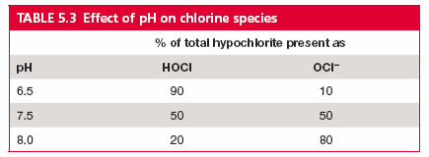

Since hypochlorous acid is the better killing agent, it would be better to keep the pH at 6.5 or lower to get the more killing power. This means adding an acid to lower the pH. Unfortunately below a pH of 7, water stings our eyes and irritates our skin because it is too acidic. In swimming pools, the pH is kept between 7.2 and 7.8
and the amount of chlorine has to be increased to get enough hypochlorous acid for quick disinfection. This makes disinfecting and cleaning the pool more expensive.

In summary:

■ If pH is too low (below 7):

  - water is acidic
  - disinfection is better and therefore cheaper
  - eye irritation occurs
  - plaster walls are etched
  - metal fittings, pump impeller, heater core may corrode
  - dissolved metals may leave stains on walls.

■ If pH is around 7.5, disinfection is more expensive, but pool is more comfortable.

■ If pH is too high (above 8):

  - chlorine activity is slowed and inefficient, more algae and micro-organisms can grow
  - scale formation increases and there can be discoloration of pool walls
  - water becomes cloudy
  - filter is overworked
  - eye irritation may occur.

Another problem is that, as people swim and other materials get into the pool, the pH changes.

As things rot, they make acids or bases. People’s sweat and body oils are mostly acidic in nature.
Urine is basic, and both urine and body oils put chemicals into the pool that react with the
chlorine and reduce its effectiveness. Because of this we must keep testing the pH, adding acid
and base as needed.
TABLE 5.4 Factors that affect pH

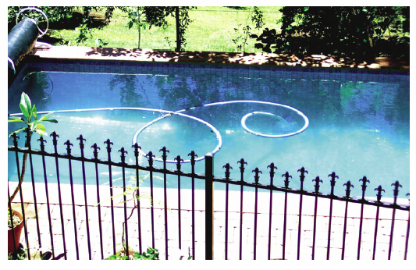
Supporting Questions

Calcium hypochlorite is often added to swimming pools to keep the water sterile and prevent health problems. When the calcium hypochlorite has been added, the pH of the water must be checked and if necessary adjusted. The ideal pH of pool water is 7.5.

1. Write the chemical formula for calcium hypochlorite. ______________________________

2. Write the chemical formula for hypochlorous acid. __________________________

3. Adding calcium hypochlorite to pool water results in the formation of hypochlorous acid.

i State the action of hypochlorous acid that allows it to kill bacteria in the water.

________________________________________________________________

ii Write the equation showing the dissociation of calcium hypochlorite.

iii Write the equilibrium equation that then shows the formation of hypochlorous acid.

iv Is the resulting solution acidic or basic? _______________________________________

v Explain why the pH of the pool water must be regularly checked.

_________________________________________________________________________

_________________________________________________________________________

_________________________________________________________________________

_________________________________________________________________________

vi Name a chemical that could be added if the pH was found to be too high.

______________________________________________

vii Describe the possible problems if the pH is too high.

_________________________________________________________________________

_________________________________________________________________________

_________________________________________________________________________

viii Calculate the hydrogen ion concentration (H⁺) of pool water with a pH of 7.5.

4. Write a sentence that describes flocculation.

__________________________________________________________________________________

__________________________________________________________________________________

