Stage 2 Chemistry

**Monitoring the Environment:** Photochemical Smog

**Science Understanding**

* Nitrogen oxides are formed in high-temperature engines and furnaces.
* Write equations for the formation of nitrogen oxides NO and NO2.
* Nitrogen oxides and ozone are pollutants in the troposphere that are associated with photochemical smog.
* Describe and write equations showing the role of nitrogen oxides in the formation of ozone in the troposphere.
* Describe the harmful effects of nitrogen oxides and ozone in the troposphere.
* Describe and write equations showing how catalytic converters reduce the quantities of nitrogen oxides generated by motor vehicles.

**Nitrogen oxides are formed in high-temperature engines and furnaces.**

Nitrogen comprises 78% by volume of the atmosphere. It exists as stable triple covalently bonded N2 molecules and is chemically very stable.

Nitrogen molecules require a large _____________________________ in order to react.

This can occur naturally in the case of _________________________

It can also occur in _____________________________ and ________________________________

Nitrogen then reacts with oxygen in the air to form nitrogen monoxide:

Nitrogen monoxide is an example of a ________________________________, as it is a substance that is directly released into the atmosphere from human activity.

The nitrogen monoxide molecule will rapidly react with oxygen to form nitrogen dioxide:

Nitrogen dioxide is an example of a ___________________________________, as it is formed from the reaction of a primary pollutant with a chemical such as water, oxygen or sunlight.

**Nitrogen oxides and ozone are pollutants in the troposphere that are associated with photochemical smog.**

The formation of photochemical smog tends to be favoured by particular weather conditions, especially windless, sunny days, and when temperature inversions occur. Normally, warm air near the Earth’s surface will rise and carry any smog with it, dispersing it into the atmosphere.

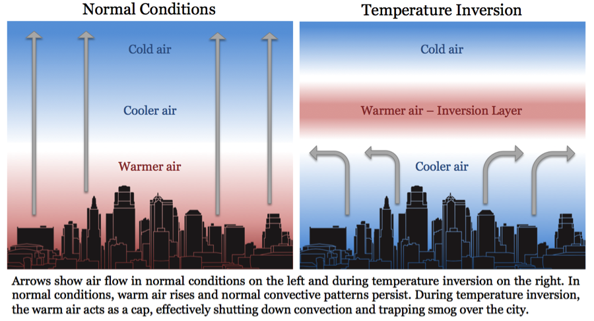Temperature inversions begin on calm, clear nights when the Earth’s surface cools rapidly as heat radiates away from it. The air near the ground becomes colder than the air higher up and this denser, colder layer becomes trapped by the warmer air above it.

Any smog formed during the day in this bottom layer is also trapped and this gives more time for the reactions between the sunlight and the gases which produce smog to increase the concentrations of pollutants. These conditions can last for several days until the smog is dispersed by winds.

Photochemical reactions are those that are initiated by the absorption of light. An example of a photochemical reaction is the formation of ozone from nitrogen oxides.

NO2

O + O2

1. Explain why a temperature inversion increases the amount of ozone produced in the troposphere

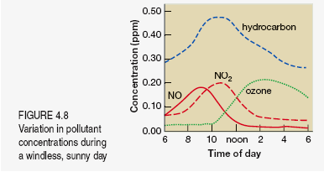

1. Explain why the maximum level of ozone tends to occur sometime after the morning “rush hour”

**Describe the harmful effects of nitrogen oxides and ozone in the troposphere.**

Ozone has several harmful effects on plant and animal health

* It can yellow plant leaves and cause a reduction in the rate of photosynthesis
* It is a respiratory irritant, causing wheezing, coughing and constriction of airways

Oxides of nitrogen have similar effects, while also being a major contributor to the formation of acid rain.

NO2 + H2O

**Catalytic Converters**

Catalytic converters were developed to reduce the amount of pollutants coming from the exhausts of cars and trucks.

These pollutants include nitrogen oxides (NO and NO2), unburnt hydrocarbons and carbon monoxide.

Catalytic converters often use an alloy of platinum and rhodium as the catalyst metal to convert nitrogen oxides into nitrogen and carbon dioxide

NO + CO

NO + H2

1. Explain why catalytic converters are often a honeycomb like structure
2. Explain why the rate of reaction of the catalytic converter increases as the engine warms up
3. How do catalytic converters reduce the amount of photochemical smog that forms