Stage 2 Chemistry

Birdwood
HIGH SCHOOL Topic 1: Monitoring the Environment
Chemists Calculating and Stoichiometry
Review Paper 4
DUE DATE:

Question 1

i Calculate the oxidation number of the element in bold in each of the following:

a Cu²⁺ b N₂O₄ c CrO₄²⁻

d Pb e F₂ f HPO₄²⁻

ii Aluminium can be used in flash bulbs to produce an intense burst of light.
Aluminium is produced in the process. The equation for the reaction is:
4Al_{(s)} + 3O_{2(g)} 2Al₂O_{3 (s)}

State the mole ratio of oxygen to aluminium oxide in this reaction.

iii Palmitic acid is the main component of the oil found in palm trees. [See diagram below.]
It has the molecular formula: CH₃(CH₂)₁₄COOH.

Show by using the molar mass, that the percentage of carbon in palmitic acid is approximately 75%. (5 marks)
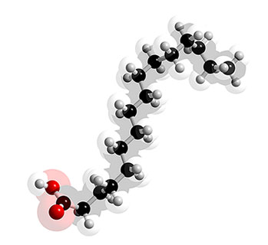

Question 2

Calculate the mass (in grams), of 0.025 mol of
iron (II) chloride, FeCl₃. (3 marks) (3 marks)

Question 3

1.48 g of potassium carbonate, K₂CO₃, is dissolved in distilled water to make a solution of volume 200.0 mL.
Calculate the concentration of this solution in mol L⁻¹. (3 marks)
(3 marks)

Question 4

Calculate the mass of copper nitrate, Cu(NO₃)₂ needed to
prepare 250 mL of a 0.25 mol L⁻¹ solution. (2 marks)
Question 5

Calculate the number of moles in 25 mL of 2.0 molL⁻¹ potassium chloride solution. (2 marks)

Question 6

The combustion of octane in excess air can be represented by the equation:

2C₈H_{18(g)} + 25O_{2(g)} 16CO_{2(g)} + 18H₂O_{(l)}

i State the reacting mole ratio of octane, C₈H₁₈, to carbon dioxide.

ii Hence find the mass of octane, in grams, that would be needed to be burnt to produce 1000 g of CO₂.
(4 marks)

Question 7
Credit will be given for the correct use of significant figures in answers to question 7. (1 mark)

The process of respiration can be represented by the equation:

C₆H₁₂O_{6 (aq)} + 6O_{2(g)} 6CO_{2(g)} + 6H₂O_{(l)}

i Calculate the mass of glucose, C₆H₁₂O₆, required to prepare 200.0 mL of a solution with a
concentration of 0.200 mol L⁻¹.

ii When a 10.0g glucose tablet completely reacts with oxygen according to the equation above,
calculate the mass of water produced.

iii If the density of water is approximately 1.00 gmL⁻¹,
convert the mass of water produced in part ii to a volume in mL. (6 marks)

Question 8

Consider the reaction represented by the unbalanced equation:

Ag_{(s)} + HNO_{3(aq)} AgNO_{3(aq)} + NO_{2(g)} + H₂O_{(l)}

i Balance the equation.

ii Name one of the reactants.

iii Calculate the mass of silver that would react with 50.0 mL of 2.50 M HNO₃.

iv Calculate the volume of 2.50 M HNO₃ that would be needed to react with 100.0 g of silver.

(8 marks)

TOTAL MARK = 34

