## **Stage 2 Chemistry**

## **Birdwood**

HIGH SCHOOL **Topic 3: Using and Controlling Reactions**

**Electrochemical Cells**

**Review Paper 15**

**DUE DATE:** Ref: ESSENTIALS pages 139 – 152



most reactive least reactive

**Question 1**

The diagram below represents a *partially completed* electrochemical cell.

Copy the diagram and use it to represent the electrochemical cell that could be constructed from the combination of half cells of iron and a solution of iron (II) nitrate and copper metal and a solution

of copper (II) sulfate.

Write the half equations for each electrode then carefully label the diagram indicating:

1. the cathode, (1 mark)

b) the charge on the cathode, (1 mark)

c) the half equation for the reaction at the anode, (2 marks)

1. the overall ionic equation for the cell reaction, (1 mark)
2. the direction of flow of electrons through the wire and, (1 mark)
3. the direction of flow of positive ions through a salt bridge of KNO3 (aq). (1 mark)
4. Would this cell be an example of a *galvanic* or an *electrolytic cell*? (1 mark)

**Question 2**

The evolution of bubbles of gas when a soft drink is opened is due to dissolved carbonic acid (H2CO3) beginning to decompose to carbon dioxide and water.

1. Write an equation to represent this process. (2 marks)
2. The evolution of gas is initially fast, but gradually slows down with time.

Explain using collision theory, why the rate of carbon dioxide evolution decreases. (3 marks)

**Question 3**

Aluminium of very high purity may be used as the anode in a proposed, aluminium – air cell. Air is bubbled through the solution at the cathode. The cell can be used to provide electricity to power small. The equations for the reactions that occur at each electrode are given below.

Al + 3OH− → Al(OH)3 + 3e−

O2 + 2H2O + 4e− → 4OH−

1. Draw a diagram to show how a cell such as this could look (3 marks)
2. Use oxidation numbers to show that the aluminium is being oxidized at the anode. (2 marks)
3. Write the equation for the overall cell reaction. (2 marks)
4. Does this aluminium-air cell represent a galvanic or an electrolytic cell? (1 mark)

1. State the *energy change* that occurs in this type of cell. (1 mark)
2. State why this type of cell cannot be classified as a fuel cell. (1 mark)
3. If we assume a small car could be powered by this type of cell, calculate the *mass of aluminium* consumed at the anode if 3.0 litres of water (density of 1 g per mL) is consumed at the cathode.

[*Assume there is no loss of water from the cell as a result of evaporation*.] (3 marks)

**Question 4**

Chlorine is a toxic greenish-yellow gas that will kill in minutes. It affects eyes and lungs at a concentration of only 3 ppm in air. At 50 ppm it is dangerous to breathe even for a short time. At 500 ppm, it can be fatal in less than10minutes. Convert 500 ppm chlorine gas (Cl2) to mol L-1.

(2 marks)

**Question 5**

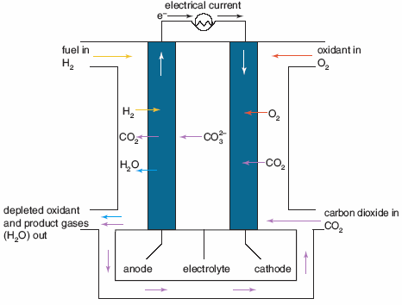

The diagram opposite shows a simplified representation of an electrochemical cell which evolved from work in the 1960’s. It operates at temperatures of about 6500C and uses a molten carbonate salt as the electrolyte which at these temperatures, liquefies and becomes a good ionic conductor.

a) Is this an example of an

electrolytic or a

galvanic cell?

b) Identify the two products

formed at the anode.

c) Give a reason why this

cell can be classified as a

fuel cell.

d) At present, fuel cells are not widely used as an energy source.

State one factor that is the most likely reason for their limited use.

1. The half-equation for the reaction at the cathode is shown below:

O2(g) + 2CO2(g) + 4e- 2CO32-

State whether the equation represents oxidation or reduction.

Use the half-equation above and oxidation numbers to explain your answer.

f) The performance of this cell is very temperature sensitive.

1. Describe what may happen to the molten carbonate salt electrolyte if the temperature decreases.
2. Explain how this may effect the performance of the cell.

(10 marks)

**Question 6**

The secondary cell devised by Thomas Edison (1847-1931) uses an iron anode and a nickel(III) oxide-hydroxide cathode both immersed in an electrolyte of 21% w/v potassium hydroxide.

The Edison cell is a rugged storage rechargeable galvanic cell that may receive hard treatment and yet give good service for years. It may be left uncharged indefinitely and still be recharged. It gives 1.3 V. The reaction at the anode when the cell is *discharging* is:

Fe + 2OH-(aq) Fe(OH)2(aq) + 2e-

1. Use oxidation numbers to show that oxidation is occurring at the anode.
2. Write the half-equation occurring at the cathode when the cell is *charging*.
3. When the cell is *charging*, state which electrode is the anode?

d) When the cell is *charging*, is it a *galvanic cell* or an *electrolytic* cell? (4 marks)

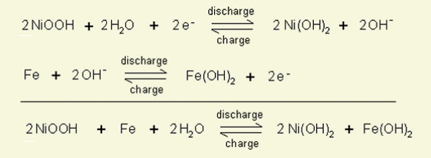

**TOTAL MARK = 39**