Stage 2 Chemistry

Birdwood
HIGH SCHOOL Topic 4: Organic & Biological Chemistry
Amines, Amides, Esters, Proteins, Triglycerides
Review Paper 9
DUE DATE: Ref: ESSENTIALS pages 252 - 271

Question 1

Pheromones are chemicals used by insects to communicate with other insects of the same species. The structural formula (A), shown below is of a pheromone secreted by the potato tubeworm moth.

O

CH₃(CH₂)₄CH CHCH₂CH CH(CH₂)₃OCCH₃

i The pheromone shown above is classified as an ester. Circle the ester functional group on the diagram above.

ii Would the alcohol from which compound A could be prepared in a laboratory be classified as primary, secondary or tertiary?
Primary
iii State the systematic name of the carboxylic which was used to prepare compound A.
ethanoic acid
iv A can be converted into a saturated compound using hydrogen.

a State the name given to this process.
hydrogenation
b A catalyst is used in this process. Give a reason for the use of a catalyst.
Lowers the activation energy of the reaction
c Write the structural formula of a saturated compound that could be formed from A. (6 marks)
O
||
CH₃ (CH₂)₁₂ –O –C – CH₃
Question 2

i Explain the meaning of the term amino acid, [Make 2 clear points.]
Contains an amine group and a carboxylic acid along with a side chain
ii Name the two functional groups present in all amino acids.
Amine and carboxylic acid
iii Amino acids can self-ionise. Briefly explain what this means.
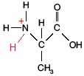
As an amino acid contains both an acid and a base, these can react with each other, the proton from the acid transferring to the basic amine group. This leaves the carboxyl group with a negative charge and the amine with a positive charge
iv Write a structural formula for the self-ionised form of the
amino acid shown in the diagram below.
(6 marks)
Question 3

Proteins are made up of amino acid units joined together. The structural formula of a fragment of a plant protein made up of different amino acid units is shown below:

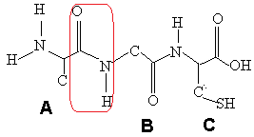

i Proteins have two other general names. State one of these names.
Polypeptides or polyamides
ii This fragment of plant protein is made up of three different amino acids linked together.

a State the special name given to this link in a protein molecule.
peptide
b Circle and label one amide group in the protein fragment shown above.

c Draw a diagram of the four atoms that make up this link showing the polarity of the bonds.
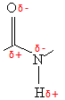
iii The unit labeled A in the above diagram is derived from the amino acid alanine. Draw the
structural formula of alanine.
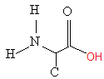
iv The two protein strands are cross linked by two different types of bonds in two different ways:
by a disulfide link and by a hydrogen bond.
On the structure above:
a Indicate the polarity of the hydrogen bond by using delta notation.
Second strand not shown, but polarity is the same as iic.
b Indicate another hydrogen bond on the diagram by using the same notation.
Each amide group is capable of hydrogen bonding (The N-H section)
c C could form a disulfide link with another sulfur containing amino acid, comment on the relative strength of the disulfide link compared to hydrogen bonding
A disulfide bridge is a primary bond (covalent) and so is going to be stronger than any of the secondary interactions, including hydrogen bonding.
v The amino acids represented by the units A and B could bond together to form a polymer.

a Draw the structural formula of the resulting polymer, using two units each of A and B, alternating along the chain.
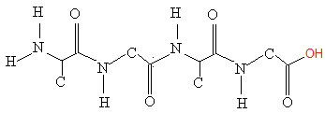

b Write the formula of the small molecule that will be released when the amino acids condense to form the polymer.
H₂O
vi Describe how excessive heating can severely affect the plant protein’s ability to function correctly.
Heat provides energy to the bonds in the protein and may enable some of them to break. By altering any of the bonds in the protein, its shape will be changed and it can no longer perform its intended function.
(12 marks)
Question 4

A popular remedy for a headache is a dose of paracetemol.
The structure of paracetemol is shown.

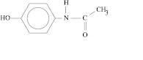

The alkaline hydrolysis of paracetemol results in the formation of two products.
Draw the structural formula of one of these products.
(2 marks)
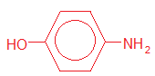
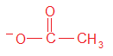

note that alkaline hydrolysis gives amine and carboxylate ion
Question 5

A plant known to the Chinese as Ma Huang or Ephedra, provided them with a medicine that was described in 2760 BC as a valuable remedy for coughs and as a cardiac stimulant. The active ingredient of this plant is ephedrine, whose structure is shown below. In an attempt to find a synthetic equivalent to ephedrine, in 1933 the compound amphetamine was found to have similar properties.
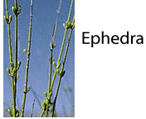
Both of these compounds react with hydrochloric acid, HCl_{(aq)}.

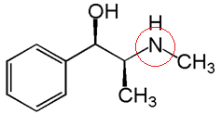
ephedrine

i Circle the part of the ephedrine molecule on the diagram above that would react with an aqueous
solution of hydrochloric acid.

ii Is ephedrine a primary, secondary or tertiary amine?
secondary
iii Draw the protonated form of ephedrine as it would form in a reaction with hydrochloric acid.

iv Describe why ephedrine in its protonated form is now much more soluble.
Being protonated ephedrine can now form strong ion-dipole interactions with water. As the strength of the secondary bonds to water is increased, its solubility is similarly increased. (5 marks)

TOTAL MARK = 31

