## **Stage 2 Chemistry**

## **Birdwood**

HIGH SCHOOL **Topic 4: Organic & Biological Chemistry**

**Amines, Amides, Esters, Proteins, Triglycerides**

**Review Paper 13**

**DUE DATE:** Ref: ESSENTIALS pages 252 - 271

**Question 1**

Pheromones are chemicals used by insects to communicate with other insects of the same species. The structural formula (**A**), shown below is of a pheromone secreted by the potato tubeworm moth.

O

CH3(CH2)4CH CHCH2CH CH(CH2)3OCCH3

i The pheromone shown above is classified as an ester. Circle the ester functional group on the diagram above.

ii Would the alcohol from which compound **A** could be prepared in a laboratory be classified as primary, secondary or tertiary?

iii State the systematic name of the carboxylic which was used to prepare compound **A**.

iv **A** can be converted into a saturated compound using hydrogen.

a State the name given to this process.

b A catalyst is used in this process. Give a reason for the use of a catalyst.

c Write the structural formula of a saturated compound that could be formed from **A**. (6 marks)

**Question 2**

i Explain the meaning of the term *amino acid*, [Make 2 clear points.]

ii Name the *two* functional groups present in all amino acids.

iii Amino acids can self-ionise. Briefly explain what this means.

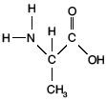

iv Write a structural formula for the self-ionised form of the

amino acid shown in the diagram below.

(6 marks)

**Question 3**

Proteins are made up of amino acid units joined together. The structural formula of a fragment of a plant protein made up of different amino acid units is shown below:

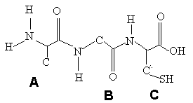

i Proteins have two other general names. State *one* of these names.

ii This fragment of plant protein is made up of three different amino acids linked together.

a State the special name given to this link in a protein molecule.

b Circle and label one **amide group** in the protein fragment shown above.

c Draw a diagram of the four atoms that make up this link showing the *polarity* of the bonds.

iii The unit labeled **A** in the above diagram is derived from the amino acid alanine. Draw the

structural formula of alanine.

iv Two protein strands like that above could be cross linked by two different types of bonds:

*by a disulfide link and by a hydrogen bond*.

On the structure above:

a Indicate the polarity of a possible hydrogen bond by using delta notation.

b **C** could form a disulfide link with another sulfur containing amino acid, comment on the relative strength of the disulfide link compared to hydrogen bonding

v The amino acids represented by the units **A** and B could bond together to form a polymer.

a Draw the structural formula of the resulting polymer, using **two units each of A and B**, alternating along the chain.

b Write the formula of the small molecule that will be released when the amino acids condense to form the polymer.

vi Describe how excessive *heating* can severely affect the plant protein’s ability to function correctly.

(12 marks)

**Question 4**

A popular remedy for a headache is a dose of paracetemol.

The structure of paracetemol is shown.

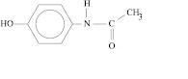

The alkaline hydrolysis of paracetemol results in the formation of two products.

Draw the structural formula of one of these products.

(2 marks)

**Question 5**

A plant known to the Chinese as Ma Huang or Ephedra, provided them with a medicine that was described in 2760 BC as *a valuable remedy for coughs and as a cardiac stimulant*. The active ingredient of this plant is **ephedrine**, whose structure is shown below. In an attempt to find a synthetic equivalent to ephedrine, in 1933 the compound amphetamine was found to have similar properties.

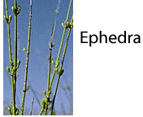

Both of these compounds react with hydrochloric acid, HCl(aq).

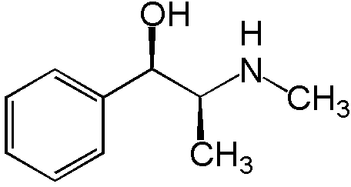

ephedrine

i Circle the part of the ephedrine molecule on the diagram above that would react with an aqueous

solution of hydrochloric acid.

ii Is ephedrine a primary, secondary or tertiary amine?

iii Draw the *protonated form* of ephedrine as it would form in a reaction with hydrochloric acid.

iv Describe why ephedrine in its protonated form is now much more soluble.

(5 marks)

**TOTAL MARK = 31**