Stage 2 Chemistry

Birdwood
HIGH SCHOOL Topic 4: Organic & Biological Chemistry
Carboxylic acids, Esters, Triglycerides
Review Paper 12
DUE DATE: Ref: ESSENTIALS pages 261 - 292

Question 1 (8 marks)

Simple esters can be found in most foods and drinks. The structural formula of one such ester is shown below:

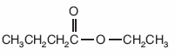

- State the common odour associated with most ester compounds.

- Draw the structural formula of the functional group in the ester shown above.

- State the systematic name of the ester shown above.

- State the systematic names of the alcohol and the carboxylic acid from which this ester is derived.

- The diagram below shows the apparatus used in the initial preparation of a typical ester.

  - What special name is given to the way this apparatus is set up?

  - State the two main reasons why this set up is
used in the preparation of an ester?

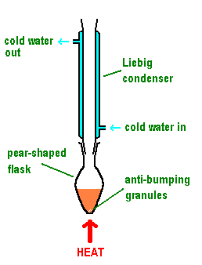

Question 2

Banana flavouring in milkshakes and icecreams can be obtained using the substance:

CH₃COO(CH₂)₄CH₃

a) Write the systematic name of this compound.

b) Write a balanced equation for the alkaline hydrolysis of this compound.
(4 marks)

Question 3

The fragrance of raspberries is due mainly to the presence of the ester ethyl methanoate.

- Write the name of the acid from which this ester could be prepared.

b) Draw the structural formula of ethyl methanoate.

c) To prepare the ester in the laboratory requires reacting a carboxylic acid with an alcohol in the presence of a
small amount of concentrated sulfuric acid.

i Write a balanced equation for the preparation of ethyl methanoate.

ii State one of the functions of the sulfuric acid. (7 marks)

Question 4

Olive oil is a popular cooking oil used in many countries around the world. The structure of palmitoleic acid, a fatty acid found in olive oil is shown below:
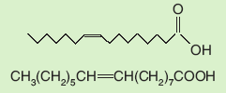

i Write the molecular formula for palmitoleic acid.

ii Draw the structural formula of the molecule of the triglyceride formed exclusively from palmitoleic acid and
propane-1,2,3-triol.

iii Describe how the structure of this oil suggests that this triglyceride is derived from plants and not animals.

iv Name the reagent and describe the conditions required to convert an oil such as olive oil into a higher melting point “margarine”.
(7 marks)

Question 5

Many analgesics (pain relieving drugs) contain aspirin. The structure of aspirin is shown below.

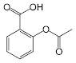

- Circle the ester functional group found in aspirin.

- Circle the acidic hydrogen on the functional group that gives aspirin acidic properties.

- If aspirin was used in the molecular form above, it would be ineffective because it is relatively insoluble. To be effective, aspirin must be in a soluble form.

i Describe the section of the structural formula of aspirin that makes it insoluble in water?

ii Aspirin is sold in solid form, mixed with a base, eg NaHCO₃. This greatly increases the effectiveness of aspirin. Use the “acidic” part on the aspirin molecule to describe how the addition of a base can change aspirin into a soluble form.

(6 marks)

Question 6

Ice-creams and milkshakes also contain a variety of solids dissolved or suspended in water. One type of solid dissolved is sugars such as glucose and sucrose.
Sucrose is a sugar found in sugar cane plants. It is formed when glucose combines with fructose.
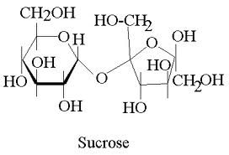

i Draw the structural formula for fructose.

ii Does fructose conform to the general formula of a carbohydrate?

iii What other piece of information would you need to have before deciding if fructose was classified as a
carbohydrate?
(6 marks)

TOTAL MARK = 38

