## **Stage 2 Chemistry**

## **Birdwood**

HIGH SCHOOL **Topic 4: Organic & Biological Chemistry**

**Aldehydes, Ketones, Carboxylic Acids**

**Review Paper 11**

**DUE DATE:**

**Question 1**

The preparation of organic compounds often requires the use of specific glassware and apparatus unique to the process. The process could be a *reflux, distillation, controlled oxidation* or a *liquid-liquid extraction*.

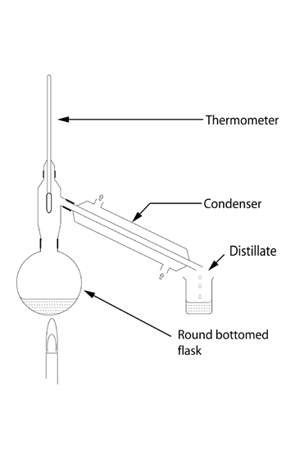

1. Write a sentence to describe the *purpose of distillation*.

Separating a mixture of chemicals according to their boiling point

1. Upon what important physical property of the solution in the round-bottomed flask, does distillation rely?

Different boiling points

1. When distilling, describe the reason for using:
   1. pumice in the round-bottomed flask.

Stops the liquid in the flask from “bumping” which could lead to the undistilled liquid reaching the condenser

* 1. the condenser.

Condenses the distilled gas back into a liquid so that it can be collected

1. Describe the direction of the flow of water through the

condenser.

Cold water flows into the lower end and flows out the upper end

(6 marks)

**Question 2**

Propanoic acid is a common carboxylic acid found in most laboratories.

1. Write a balanced equation for the reaction of propanoic acid with potassium carbonate solution.

2CH3CH2COOH + K2CO3 -> 2CH3CH2COOK + H2O + CO2

b) Describe the observation that would indicate a reaction had occurred. (3 marks)

CO2 bubbles

**Question 3**

The compounds X (butanal) and Y (butanone), have the same molecular formula but different structural formula.

1. Write the molecular formula of butanal.

C4H8O

1. Write the structural formula for butanone.

CH3CH2CH2CH=O

1. State the term used to describe the relationship between X and Y.

Structural isomer

1. When X reacts with ammoniacal silver nitrate solution, the organic species Z is formed.

Give the *systematic name* of species Z. butanoate ion (4 marks)

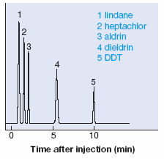**Question 4**

High performance liquid chromatography, using a non-polar stationary phase, was used to separate five components of a weed herbicide. The chromatogram obtained, showing the retention times, is shown opposite.

a) State the meaning of the term “retention time”.

The time that it takes for the chemical to pass through the chromatography column

b) Identify which, of dieldrin and DDT, is the less polar compound

and explain your answer.

The mobile phase is the polar phase. The more polar chemical will form stronger interactions with the polar phase and so will pass through the column quicker. As diedrin has a lower retention time it will therefore be the more polar compound, meaning that DDT is the less polar compound.

(4 marks)

(5 marks)

**Question 5**

Write an equation to show the ionization of propanoic acid in water. (2 marks)

CH3CH2COOH + H2O CH3CH2COO- + H3O+

**Question 6**

Systematically name the following compounds.

a) CH3CH2CH2 O b) CH3

CCH3 CH3CH2CH CH CH3

O OH

Propyl ethanoate 2-methyl-pentan-3-ol

c) CH3CHCH2COOH

CH3 (6 marks)

3-methyl-butanoic acid

**Question 7**

The structures of glyceraldehyde and lactic acid are shown below:

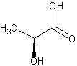 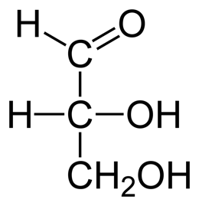

glyceraldehyde lactic acid

a) Write the molecular formula of lactic acid and show that it conforms to the general formula of a carbohydrate.

C3H6O3 It does conform to the general formula Cx(H2O)y

b) Glyceraldehyde has the same molecular formula as lactic acid and **is** classified as a carbohydrate.

Lactic acid is **not classified** as a carbohydrate.

Explain what is different about the structures of glyceraldehyde and lactic acid that makes glyceraldehyde a

carbohydrate but not lactic acid.

Conforming to the formula is not enough to classify something as a carbohydrate. It must be either a polyhydroxyaldehyde or a polyhydroxyketone. Both would be classified as poly hydroxyl, but only glyceraldehyde contains an aldehyde group, lactic acid instead contains a carboxylic acid group instead.

c) If Tollens reagent was added to separate samples of both glyceraldehyde and lactic acid, describe what

observations would be made in each case.

A silver mirror would form at the bottom of the reaction vessel for glyceraldehyde, no change would be observed for the lactic acid (5 marks)

**Question 8**

Starch, which has the structure shown below, is a complex carbohydrate made up of many glucose units linked together:

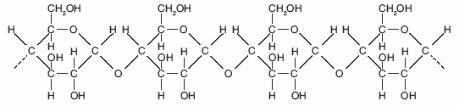

a) State the type of alcohol group indicated by the arrow in the diagram above.

Secondary

b) Draw the structural formula of the monomer from which starch is produced.

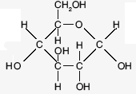

c) *Name the type of chemical reaction* that produces starch from its monomer repeatedly joined together.

Condensation

d) Starch readily absorbs water, ie water is attracted to starch. However, starch is not soluble in water.

Explain these two observations about starch.

Starch has many highly polar hydroxyl groups and can therefore form strong hydrogen bonds with water. Starch is however far to big to dissolve readily in water. The secondary interactions with water instead will cause the water to absorb onto the starch. (6 marks)

**TOTAL MARK = 36**