## **Stage 2 Chemistry**

## **Birdwood**

HIGH SCHOOL **Topic 4: Organic & Biological Chemistry**

**Aldehydes, Ketones, Carboxylic Acids**

**Review Paper 11**

**DUE DATE:**

**Question 1**

The preparation of organic compounds often requires the use of specific glassware and apparatus unique to the process. The process could be a *reflux, distillation, controlled oxidation* or a *liquid-liquid extraction*.

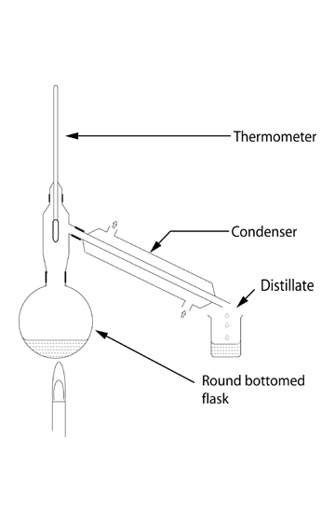

1. Write a sentence to describe the *purpose of distillation*.
2. Upon what important physical property of the solution in the round-bottomed flask, does distillation rely?
3. When distilling, describe the reason for using:
   1. pumice in the round-bottomed flask.
   2. the condenser.
4. Describe the direction of the flow of water through the

condenser.

(6 marks)

**Question 2**

Propanoic acid is a common carboxylic acid found in most laboratories.

1. Write a balanced equation for the reaction of propanoic acid with potassium carbonate solution.

b) Describe the observation that would indicate a reaction had occurred. (3 marks)

**Question 3**

The compounds X (butanal) and Y (butanone), have the same molecular formula but different structural formula.

1. Write the molecular formula of butanal.
2. Write the structural formula for butanone.
3. State the term used to describe the relationship between X and Y.
4. When X reacts with ammoniacal silver nitrate solution, the organic species Z is formed.

Give the *systematic name* of species Z. (4 marks)

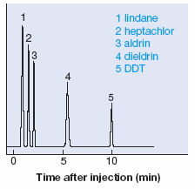**Question 4**

High performance liquid chromatography, using a non-polar stationary phase, was used to separate five components of a weed herbicide. The chromatogram obtained, showing the retention times, is shown opposite.

a) State the meaning of the term “retention time”.

b) Identify which, of dieldrin and DDT, is the less polar compound

and explain your answer.

(4 marks)

(5 marks)

**Question 5**

Write an equation to show the ionization of propanoic acid in water. (2 marks)

**Question 6**

Systematically name the following compounds.

a) CH3CH2CH2 O b) CH3

CCH3 CH3CH2CH CH CH3

O OH

c) CH3CHCH2COOH

CH3 (6 marks)

**Question 7**

The structures of glyceraldehyde and lactic acid are shown below:

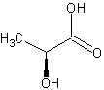 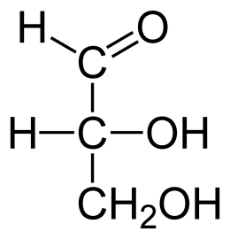

glyceraldehyde lactic acid

a) Write the molecular formula of lactic acid and show that it conforms to the general formula of a carbohydrate.

b) Glyceraldehyde has the same molecular formula as lactic acid and **is** classified as a carbohydrate.

Lactic acid is **not classified** as a carbohydrate.

Explain what is different about the structures of glyceraldehyde and lactic acid that makes glyceraldehyde a

carbohydrate but not lactic acid.

c) If Tollens reagent was added to separate samples of both glyceraldehyde and lactic acid, describe what

observations would be made in each case.

(5 marks)

**Question 8**

Starch, which has the structure shown below, is a complex carbohydrate made up of many glucose units linked together:

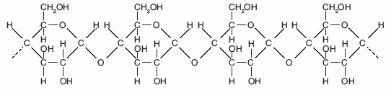

a) State the type of alcohol group indicated by the arrow in the diagram above.

b) Draw the structural formula of the monomer from which starch is produced.

c) *Name the type of chemical reaction* that produces starch from its monomer repeatedly joined together.

d) Starch readily absorbs water, ie water is attracted to starch. However, starch is not soluble in water.

Explain these two observations about starch.

(6 marks)

**TOTAL MARK = 36**