Managing Chemical Processes – practice test
- Energy Profile diagrams can be used to describe the energy changes that take place during a chemical reaction
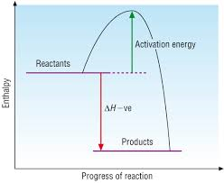
  - Draw energy profile diagrams of
    - an exothermic reaction

(2 marks)
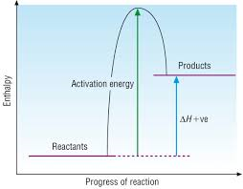
    - an endothermic reaction

(2 marks)
  - Clearly label ΔH and the activation energy on your diagrams (2 marks)
  - Explain why heat is needed initially for both types of reaction
For both reactions to proceed, an initial input of energy is required to overcome the activation energy. (1 mark)
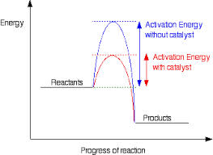
  - With the use of an energy profile diagrams describe how a catalyst affects the rate of reaction
Catalyst offers an alternative reaction pathway with a lower activation energy. As such a greater proportion of collisions will now have sufficient activation energy to react, hence the reaction rate is increased.
(3 marks)
- Ammonia is produced commercially via the Haber process
N₂ + 3H₂ ⇌ 2NH₃ ΔH = -92.4 kJ mol⁻¹
  - state the features of a reaction at equilibrium
Constant temperature, closed system, all observable factors are constant. (2 marks)
  - name two experimental conditions that will increase the rate of this reaction and using collision theory explain why these conditions lead to an increased rate
Heat – increases energy of molecules, so increases the number of collisions and the proportion of successful collisions
Pressure – effectively increases the concentration of all reactants, increases the number of collisions
Concentration – increases the number of collisions, therefore there are more successful collisions
(6 marks)
  - Use Le Chateliers principle to explain the effect of pressure on the yield of ammonia
If the pressure is increased, according to Le Chateliers principle the equilibrium will then favour the reaction with the fewer product molecules. In this case it will increase the yield of ammonia.
(3 marks)
  - Describe the effect on the yield and reaction rate by the use of a catalyst
Catalyst offers an alternative reaction pathway with lowered activation energy, which will increase the rate of reaction. A catalyst has no effect on the yield.
(2 marks)
  - If the reaction has a Kc value of 0.3 at 200°C, does the reaction have a greater proportion of reactants or products?
Kc < 1 indicates a greater proportion of reactants (1 mark)
  - The following reaction was undertaken at a temperature of 3000°C. Fill in the following table for this reaction.
 | N₂ | H₂ | NH₃
Mole Ratio | 1 | 3 | 2
Initial (mol) | 1.0 | 2.0 | 0.0
Change (mol) | 0.5 | 1.5 | 1.0
Equilibrium (mol) | 0.5 | 0.5 | 1.0
(3 marks)
  - If the reaction was done in a 10.0L reaction vessel calculate the concentrations of reactants at equilibrium
$C=\frac{n}{V}$ $C=\frac{0.5}{10}$ $C(N_{2})=0.05molL^{-1}$
$C=\frac{n}{V}$ $C=\frac{0.5}{10}$ $C(H_{2})=0.05molL^{-1}$
$C=\frac{n}{V}$ $C=\frac{1.0}{10}$ $C({NH}_{3})=0.10molL^{-1}$

(2 marks)
  - calculate Kc for this reaction
$$Kc=\frac{(0.1)^{2}}{(0.05)(0.05)^{3}}$$
Kc = 1600
(2 marks)
  - if equilibrium was established after 10 mins, draw a graph of concentration versus time for 15 mins of H₂, N₂ and NH₃ on the same graph.

(4 marks)
- Changes can be made to reactions that alter either the yield or rate.
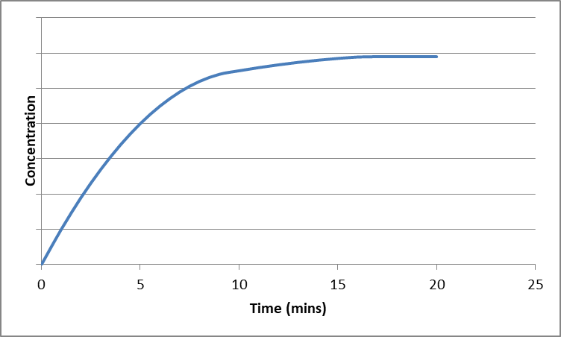
  - State the time at which the equilibrium was reached

t = 16 mins
(1 mark)
  - A change was made to the reaction conditions. The effect of the change is shown below. Identify the change that was made

Use of a catalyst

(1 mark)

  - A reaction had a Kc value of 5. When the temperature of the reaction was increased, the Kc value fell to 2. Is the reaction exothermic or endothermic? Justify your answer
Greater proportion of products at the lower temperature (Kc is higher).
Therefore the reaction is exothermic.
(2 marks)
  - Does this equilibrium mixture contain a greater proportion of reactants or products? How can you tell?
Greater proportion of products as Kc > 1.
(2 marks)
- Zinc can be obtained from the mineral hemimorphite, as shown in the flow chart below:
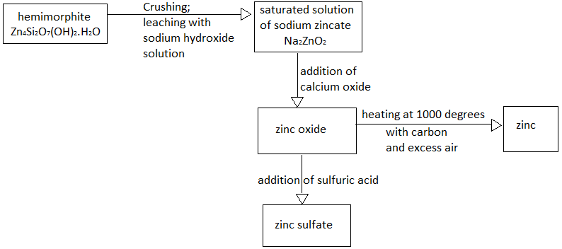

  - Name the process used to increase the rate of reaction of hemimorphite with sodium hydroxide solution.
Crushing (1 mark)
  - Write the formula of the by-product of this process
ZnSO₄ (2 marks)
  - Explain, using collision theory, why this increases the rate of reaction
Crushing increases the surface area which increases the number of collisions.
(2 marks)
  - State the function of the carbon in the conversion of zinc oxide to zinc
Accidently put this one in thinking it was a catalyst question. It actually acts as a reducing agent. This won’t be assessed (1 mark)
  - A saturated aqueous solution of sodium zincate establishes an equilibrium in which the products are zinc oxide and sodium hydroxide. Write an equation for this equation:
Na₂ZnO₂ + H₂O ⇌ ZnO + 2NaOH

(2 marks)

