Managing Chemical Processes – practice test
- Energy Profile diagrams can be used to describe the energy changes that take place during a chemical reaction
  - Draw energy profile diagrams of
    - an exothermic reaction

(2 marks)
    - an endothermic reaction

(2 marks)
  - Clearly label ΔH and the activation energy on your diagrams (2 marks)
  - Explain why heat is needed initially for both types of reaction
(1 mark)
  - With the use of an energy profile diagrams describe how a catalyst affects the rate of reaction

(3 marks)
- Ammonia is produced commercially via the Haber process
N₂ + 3H₂ ⇌ 2NH₃ ΔH = -92.4 kJ mol⁻¹
  - state the features of a reaction at equilibrium
(2 marks)
  - name two experimental conditions that will increase the rate of this reaction and using collision theory explain why these conditions lead to an increased rate

(6 marks)
  - Use Le Chateliers principle to explain the effect of pressure on the yield of ammonia

(3 marks)
  - Describe the effect on the yield and reaction rate by the use of a catalyst

(2 marks)
  - If the reaction has a Kc value of 0.3 at 200°C, does the reaction have a greater proportion of reactants or products?
(1 mark)
  - The following reaction was undertaken at a temperature of 3000°C. Fill in the following table for this reaction.
 | N₂ | H₂ | NH₃
Mole Ratio
Initial (mol) | 1.0 | 2.0 | 0.0
Change (mol)
Equilibrium (mol) |  |  | 1.0
(3 marks)
  - If the reaction was done in a 10.0L reaction vessel calculate the concentrations of reactants at equilibrium

(2 marks)
  - calculate Kc for this reaction

(2 marks)
  - if equilibrium was established after 10 mins, draw a graph of concentration versus time for 15 mins of H₂, N₂ and NH₃ on the same graph.

(4 marks)
- Changes can be made to reactions that alter either the yield or rate.
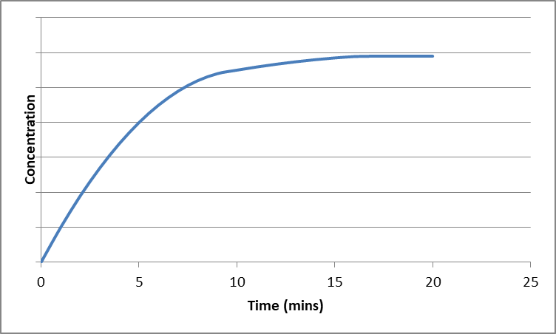
  - State the time at which the equilibrium was reached

(1 mark)
  - A change was made to the reaction conditions. The effect of the change is shown below. Identify the change that was made

(1 mark)
  - A reaction had a Kc value of 5. When the temperature of the reaction was increased, the Kc value fell to 2. Is the reaction exothermic or endothermic? Justify your answer

(2 marks)
  - Does this equilibrium mixture contain a greater proportion of reactants or products? How can you tell?

(2 marks)
- Zinc can be obtained from the mineral hemimorphite, as shown in the flow chart below:
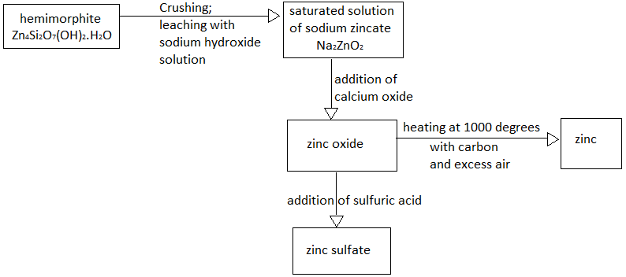

  - Name the process used to increase the rate of reaction of hemimorphite with sodium hydroxide solution.
(1 mark)
  - Write the formula of the by-product of this process
(2 marks)
  - Explain, using collision theory, why this increases the rate of reaction

(2 marks)
  - State the function of the carbon in the conversion of zinc oxide to zinc
(1 mark)
  - A saturated aqueous solution of sodium zincate establishes an equilibrium in which the products are zinc oxide and sodium hydroxide. Write an equation for this equation:

(2 marks)

