Organic Chemistry Practice Test B

1. a) Systematically name glycerol
propan-1,2,3-triol

b) What name is given to compounds of 3 fatty acids with glycerol
Triglyceride

c) A fatty acid has the molecular formula of C₁₂H₂₀O₂. Draw 2 possible isomers of this fatty acid

CH₃-CH₂-CH₂-CH=CH-CH₂-CH=CH-CH₂-CH₂-CH₂-COOH

CH₃-CH₂-CH=CH-CH₂-CH=CH-CH₂-CH₂ CH₂-CH₂-COOH

d) Draw the product of the following reaction
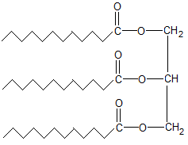
3 C₁₂H₂₀O₂ + C₃H₈O₃ + 3H₂0
Fatty acid glycerol

e) What small molecule was also a by-product of this reaction

water

2. a) Circle one peptide link on the diagram below
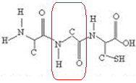

b) How many different amino acids were used to make up this polypeptide chain?
3

c) Draw the structural formula of one of these amino acids
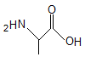

3. Identify a reagent that could distinguish between
a) an alcohol and an aldehyde
Tollen’s silver mirror with aldehyde

b) a ketone and an alcohol
dichromate orange to green with alcohol

c) a ketone and an aldehyde
Tollen’s silver mirror with aldehyde

d) a ketone and a carboxylic acid
carbonate CO2 bubbles with carboxylic acid

e)What would your observation be in each case?

4. a) The diagram below is oleic acid, circle the carboxylic acid functional group
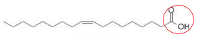

b) Draw the structure of oleic acid after it undergoes an addition reaction with bromine solution.

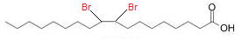

5. One of the steps in the isolation of an ester is to separate it from a mixture of left over carboxylic acid.

a) aqueous sodium carbonate is added to the acid/ester mixture. Explain how this will help to separate the acid and ester. (hint: solubility)

Removes the acidic hydrogen. This leaves the acid with a full negative charge. It is then able to form ion-dipole interactions with water, which are much stronger than the previous hydrogen bonds. As it forms stronger interactions with the water it will dissolve more easily.

b) What apparatus would be used for this separation?
Separating funnel

6. The tertiary structure for two polypeptides is different. Polypeptide A has hydrogen bonds and ion-dipole bonds from carboxylate ions. Polypeptide B has a disulfide bridge.
a) comment on the relative strength of the bonds in polypeptides A and B

disulphide bridge is a primary bond and so will be much stronger than the ion-dipole secondary interactions

b) how would each of the tertiary structure of the two polypeptides be affected by an acidic environment?

The carboxylate ion would accept a proton from the acidic environment. This would mean that it can no longer form ion-dipole bonds and will likely form hydrogen bonds instead. These weaker bonds will not hold the protein in the same 3D shape that the ion-dipole bonds would, ie its tertiary structure would be disrupted.

7. Ethanal can be synthesised by the controlled oxidation of ethanol

a) What reagent is used for this oxidation?

Acidified potassium dichromate

b) The separation of ethanal and ethanol is achieved through distillation, explain the difference in boiling points of the two chemicals

Ethanol can form hydrogen bonds due to its hydroxyl group, while ethanal can only form dipole-dipole interactions. As hydrogen bonds are stronger, they require more energy to break, leading to higher boiling points.

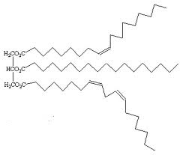
8. The adjacent picture is that of a triglyceride.

a) Is this triglyceride saturated or unsaturated?

unsaturated

b) With reference to the secondary interactions, explain whether this molecule would be a solid or liquid at room temperature

As an unsaturated triglyceride, this molecule cannot pack together as tightly as a saturated triglyceride. This extra space between the molecules leads to weaker dispersion forces. As the secondary interactions are weaker it requires less energy to break and therefore is more likely to be a liquid at room temperature

9. There are numerous isomers of C₄H₁₁N. Draw
a) a primary amine

b) a secondary amine
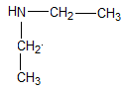

c) a tertiary amine
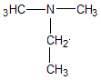

d) Each of these amines can act as a mild base. Draw the protonated form of each amine
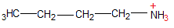
a)

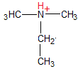
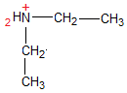
b) c)

10. a) Draw and name the two reactants that could be used to produce N- ethyl-acetamide by condensation
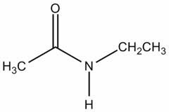

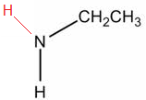
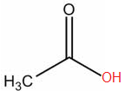

Ethanoic acid ethyl-amine

b) What would be the other product of this reaction?

water

c) The solubility of this compound can be improved by a reaction with an acid solution. With reference to the structural formula explain this increase in solubility.
The nitrogen on the amide is (very slightly) basic and can accept a proton. This leads to the ability to form ion-dipole interactions with water, leading to an increase in solubility.

Note that amides are extremely weak bases and this question is more a result of me not thinking it through. Generally treat amides as being unable to accept a proton.

