Organic Chemistry Practice Test A

1. a) Draw a TLC plate where one compound X has been separated into 3 constituents, A, B and C, with Rf values 0.4, 0.6 and 0.7.

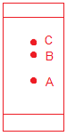

b) Assuming the stationary phase was more polar, which of the 3 compounds was the most polar.

Component A would be the most polar.

c) If the three compounds were propanol, propanal and propanoic acid, label them as A, B and C

A = propanoic acid, B = propanol, C= propanal

2. a) Name the following compound (D)

b) Through controlled oxidation this compound can be oxidized to form another compound E. Draw and name compound E.
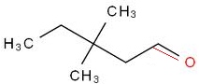

c) What reagent would be used for this reaction?

Acidified dichromate solution

d) Describe a test to distinguish between compound E and 3,3-dimethyl-pentan-2-one.

Reaction with ammoniacal silver nitrate (Tollen’s reagent) solution. A positive test for aldehydes is a silver mirror at the base of the reaction vessel, ketones will produce no change

e) What is the name given to the relationship between these two compounds?

Structural isomers

f) Draw the product of the test in part d)

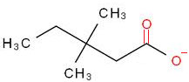

Note the product is the carboxylate ion as Tollen’s is carried out in basic conditions.

3. Potassium dichromate is a common oxidation agent for the oxidation of organic compounds, write a balanced half equation for the reduction of dichromate to chromium ions (Cr³⁺)

Cr₂O₇²⁻ -> 2Cr³⁺ balance other than H and O
Cr₂O₇²⁻ -> 2Cr³⁺ balance O by adding H₂O
Cr₂O₇²⁻ -> 2Cr³⁺ + 7H₂O balance H by adding H⁺
Cr₂O₇²⁻ + 14H⁺ -> 2Cr³⁺ + 7H₂O balance charge by adding e⁻
Cr₂O₇²⁻ + 14H⁺ + 6e⁻ -> 2Cr³⁺ + 7H₂O

4. a) Propanoic acid was tested with sodium hydroxide, sodium carbonate and sodium hydrogen carbonate. Write a balanced equation for each of these reactions

CH₃CH₂COOH + NaOH -> CH₃CH₂COONa + H₂O
2CH₃CH₂COOH + NaCO₃ -> 2CH₃CH₂COONa + H₂O + CO₂
CH₃CH₂COOH + NaHCO₃ -> CH₃CH₂COONa + H₂O + CO₂

b) What observation would you see for each reaction?

1 = no observation
2 = bubbles
3 = bubbles

5. a) Does the molecular formula of glucose and fructose conform to the general formula for carbohydrates?
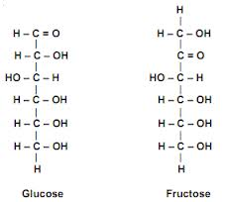

C₆H₁₂O₆ does conform to C_{x}(H₂O)_{y}

Remember this is not enough to say that they are carbohydrates

b) Would ammoniacal silver nitrate (Tollen's reagent) react with these sugars?

Would react with glucose due to the aldehyde functional group. It would not react with fructose.

c) Why does the ammoniacal silver nitrate not react with the other functional groups in either sugar?

Tollen’s reagent is a weak oxidizer and is not strong enough to oxidise the alcohol functional groups. It cannot oxidise the ketone as there are no oxidation products of a ketone

6. a) Name the following compound

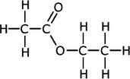

b) The process to make this compound involves the reflux of two chemicals, name them.

Ethanoic acid and ethanol

c) This process is an equilibrium, so all species are present at the end of the reaction. Part of the separation process is distillation. Account for the difference in boiling point of the 3 chemicals present. (ignore water and acid catalyst)

Three products present are ethanol, ethanoic acid and ethyl ethanoate. Difference in boiling points is due to the relative strength of the secondary bonds, the stronger the bonds the higher the boiling point. Ethyl ethanoate can only form dipole-dipole interactions and so, despite being the largest molecule, will have the lowest boiling point. Ethanol and ethanoic acid can both form hydrogen bonds, but they will be stronger in the ethanoic acid due to the addition of the polar carbonyl group.

7. a) The molecule below, alanine, contains two functional groups. Name them.

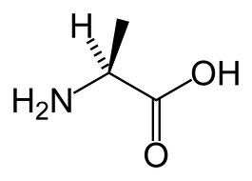

Amine and carboxylic acid

b) When dissolved in water alanine self ionizes. Draw the ionized version of this molecule.
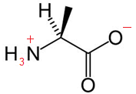

8. a) Ethanol can be made from the fermentation of glucose. Write an equation for this reaction.
yeast
C₆H₁₂O₆ ---------> 2C₂H₅OH + 2CO₂

b) What conditions does this reaction require?

Yeast requires aqueous conditions that are
- Mildly acidic
- Warm (25-30º)
- Anaerobic

c) What happens if these conditions are not met?

The yeast function best in warm mildly acidic conditions. Straying too far from these could result in the yeast dying, which will halt the reaction. Aerobic conditions will allow the yeast to follow a different metabolic pathway that does not produce ethanol.

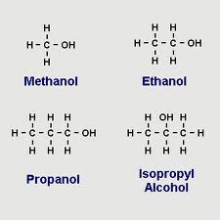
9. a) Label the following alcohols as primary, secondary or tertiary

methanol – 1º

ethanol – 1º

propanol – 1º

isopropyl alcohol – 2º

b) Systematically name the two propanol compounds

propan-1-ol and propan-2-ol

10. Cellulose and starch are examples of polysaccharides made from repeating units of glucose

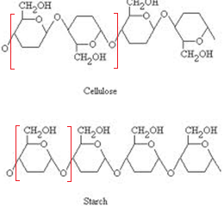

On the above diagram label a repeating unit of each polysaccharide

11. a) What reaction could you use to distinguish between propanal and propanoic acid?

Reaction with a carbonate or hydrogen carbonate will produce carbon dioxide bubbles for the carboxylic acid and not with the aldehyde.

Alternatively you could use Tollen’s or dichromate, which will oxidise the aldehyde and not the acid. (note that you could not use this method to distinguish between a ketone and an acid, the previous method must be used)
b) write an equation for the reaction between propanoic acid and sodium hydroxide.

CH₃CH₂COOH + NaOH -> CH₃CH₂COONa + H₂O

c) 50 mL of propanoic acid was titrated with 10 mL of 0.5M NaOH, calculate the concentration of the propanoic acid

n = C V
n = 0.5 x 0.010
n = 0.05 mol of NaOH

1:1 mole ratio

n(acid) = 0.05
C = n / V
C = 0.05 / 0.05
C = 1 molL⁻¹

12. a) 3ppb of Pb was found in drinking water, convert this to mg L⁻¹

3ppb = 3μg L⁻¹
3μg L⁻¹ = 3000 mg L⁻¹

b) This sample was analysed using AAS, describe the main parts of this machine

Lamp
- the source of the monochromatic radiation.
- Made of the same material to be analysed (ie Na lamp to find Na)

Flame
- Sample is sprayed into flame
- This atomizes the sample

Filter
- Ensures that only 1 wavelength of radiation passes through to the detector

Detector
- Measures the absorbance of light from the lamp
- The drop in absorbance caused by the sample is proportional to the concentration of the sample

Refer to your notes and/or textbook for a more detailed description

