Organic Chemistry Practice Test A

1. a) Draw a TLC plate where one compound X has been separated into 3 constituents, A, B and C, with Rf values 0.4, 0.6 and 0.7.

b) Assuming the stationary phase was more polar, which of the 3 compounds was the most polar.

c) If the three compounds were propanol, propanal and propanoic acid, label them as A, B and C

2. a) Name the following compound (D)

b) Through controlled oxidation this compound can be oxidized to form another compound E. Draw and name compound E.

c) What reagent would be used for this reaction?

d) Describe a test to distinguish between compound E and 3,3-dimethyl-pentan-2-one.

e) What is the name given to the relationship between these two compounds?
f) Draw the product of the test in part d)

3. Potassium dichromate is a common oxidation agent for the oxidation of organic compounds; write a balanced half equation for the reduction of dichromate to chromium ions (Cr³⁺)

4. a) Propanoic acid was tested with sodium hydroxide, sodium carbonate and sodium hydrogen carbonate. Write a balanced equation for each of these reactions

b) What observation would you see for each reaction?

5. a) Does the molecular formula of glucose and fructose conform to the general formula for carbohydrates?
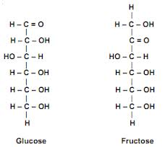

b) Would ammoniacal silver nitrate (Tollen's reagent) react with these sugars?

c) Why does the ammoniacal silver nitrate not react with the other functional groups in either sugar?
6. a) Name the following compound

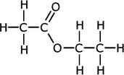

b) The process to make this compound involves the reflux of two chemicals, name them.

c) This process is an equilibrium, so all species are present at the end of the reaction. Part of the separation process is distillation. Account for the difference in boiling point of the 3 chemicals present. (ignore water and acid catalyst)

7. a) The molecule below, alanine, contains two functional groups. Name them.

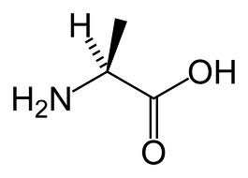

b) When dissolved in water alanine self ionizes. Draw the ionized version of this molecule.

8. a) Ethanol can be made from the fermentation of glucose. Write an equation for this reaction.

b) What conditions does this reaction require?

c) What happens if these conditions are not met?

9. a) Label the following alcohols as primary, secondary or tertiary
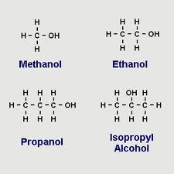

b) Systematically name the two propanol compounds

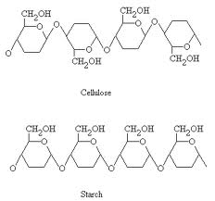
10. a) Cellulose and starch are examples of polysaccharides made from repeating units of glucose

b) On the above diagram label a repeating unit of each polysaccharide

11. a) What reaction could you use to distinguish between propanal and propanoic acid?

b) write an equation for the reaction between propanoic acid and sodium hydroxide.

c) 50.0 mL of propanoic acid was titrated with 10.0 mL of 0.50M NaOH, calculate the concentration of the propanoic acid

12. a) 3ppb of Pb was found in drinking water, convert this to mg L⁻¹

b) This sample was analysed using AAS, describe the main parts of this machine

