Stage 2 Chemistry

**Monitoring the Environment:** Optimising Production

**Science Understanding**

* Designing chemical-synthesis processes involves constructing reaction pathways that may include more than one chemical reaction.
* The steps in industrial chemical processes can be conveniently displayed in flow charts.
  + Interpret flow charts and use them for such purposes as identifying raw materials, chemicals present at different steps in the process, waste products, and by-products.
* Industrial processes are designed to maximise profit and to minimise impact on the environment.
  + Explain how certain reaction conditions represent a compromise that will give maximum yield in a short time.
  + Explain the impact of increases in temperature and pressure on manufacturing conditions and costs, and on the environment.
  + Explain how use of a catalyst may benefit both the manufacturer and the environment.

##### Selecting the operating conditions for a chemical plant

1. For an industrial chemical process to be profitable, a fast rate of reaction and a high yield is desirable so that raw materials can be quickly and efficiently converted to products.
2. *Fast rates* are brought about by:
   1. _____________________________________________
   2. _____________________________________________
   3. _____________________________________________
   4. _____________________________________________
3. For reversible reactions, a higher equilibrium yield can be increased by:
   1. __________________________for endothermic reactions
   2. __________________________for exothermic reactions
   3. __________________________of products
   4. __________________________of reactants
   5. __________________________for few product molecules
   6. __________________________for many product molecules

1. However there will be times when there is a conflict between selecting conditions for a fast rate and also a high yield, and a compromise has to be made.

As a simple example, for the reaction:

CH4(g) + 2O2 (g) ⇌ CO2 (g) + 2H2O (l)  ΔH = -5.0 x 104 kJ mol-1

A low temperature favours the ____________________________________________

However, a low temperature means reaction rate is ___________________________

1. High temperatures and pressures are often expensive to run and require expensive specialist equipment and facilities. Sometimes it is more cost effective to run at non-optimal temperatures and pressures because of this.

**An example of selecting conditions to give economical yields**

**The manufacture of ammonia, NH3 – the Haber Process**

Ammonia is an important industrial chemical, and it is manufactured in a process known as the Haber Process. Ammonia is used in agriculture as a vital ingredient for the manufacture of fertilisers and in the plastics industry.

The raw materials for ammonia production are nitrogen from the air, natural gas and water.

Natural gas is mixed with steam and converted to hydrogen and carbon dioxide. Carbon dioxide is removed, and the hydrogen combined with nitrogen in an equilibrium reaction shown below:

N2(g) + 3H2(g) ⇌ 2NH3(g) ΔH = - 92 kJmol-1

When the equation is examined:

1. Is the forward reaction endothermic or exothermic? _______________________________
2. Since all reactants and products are gases, the equilibrium will be affected by pressure.

On which side (L or R) of the equation are there a greater number of molecules? __________

**Le Chatelier’s** Principle tells us that a high yield (ie equilibrium pushed to the right) is favoured by:

1. (temperature) __________________________________________________
2. (pressure) __________________________________________________

Using these conditions the best **yield** is obtained at 2000C and at 1000 atmospheres pressure.

**HOWEVER,**

A relatively low temperature of 2000C will mean that ______________________________________

A pressure of 1000 atmospheres is _____________________________________________________

**HENCE,**

A compromise is reached between yield, rate and cost:

* A temperature in the range 3800C - 4500C is selected and an iron catalyst is used to speed up the reaction rate.
* A pressure of 200 atmospheres is chosen.

These conditions lead to a yield of about 15%.

The forward reaction is further favoured by ___________________________________________

Nitrogen and hydrogen combine in a reaction vessel and are then pumped to a cooling chamber, where the ammonia is liquefied and removed from the mixture.

Would you expect the boiling point of ammonia to be higher or lower than that of hydrogen and nitrogen?

______________________ Why? _____________________________________________________

The un-reacted gases are returned to the reaction vessel together with fresh incoming hydrogen and nitrogen.

The process occurs continuously, and means there is always a high concentration of reactants and hence favouring the forward reaction.

**Use of a catalyst**

Catalysts effect the ________________ of reaction, but have no effect on the ________________.

By increasing the rate, other less optimal conditions can be used to either improve yield or cost, such as a lower __________________ or ____________________.

Recycling ____________ to other areas of the plant and running continuously can also reduce energy costs.

By reducing energy costs, these processes also reduce the impact on the environment.

**Example Question**

During the Contact Process for the production of sulfuric acid, as SO2 gas passes through a series of catalyst beds in the converter, its temperature increases.

The gas is passed through a heat exchanger where it is cooled before it returns to go through another series of catalyst beds.

The reaction in the converter is: 2SO2(g) + O2(g) ⇌ SO3(g) ΔH = -198 kJ mol-1

1. State the function of the catalyst bed.

___________________________________________________________________________

1. Explain why there might by a series of beds and not just one for the gas to pass through.

___________________________________________________________________________

___________________________________________________________________________

1. Explain why the temperature of the gas increases in the converter.

___________________________________________________________________________

1. Explain why cooling the SO2 gas increases the yield of SO3 gas.

___________________________________________________________________________

___________________________________________________________________________

___________________________________________________________________________

1. The heat taken by the heat exchanger in cooling the gas is transferred to another part of the plant where it is used to heat the offices for staff. How will this reduce energy costs?

___________________________________________________________________________

___________________________________________________________________________

1. Describe the effect on the yield of increasing the pressure.

___________________________________________________________________________

___________________________________________________________________________

___________________________________________________________________________

___________________________________________________________________________

What is one disadvantage of using a high pressure in the above system?

___________________________________________________________________________

___________________________________________________________________________

**Describing a chemical process using a flowchart**

There are certain important terms chemists use when describing a chemical process.

Flow charts are a convenient way to display the steps in a chemical process and the terms below can be used to describe these steps.

|  |  |
| --- | --- |
| **TERM** | **DESCRIPTION** |
| **Raw Materials** |  |
| **Products** |  |
| **Waste Products** |  |
| **By-products** |  |
| **Energy Costs** |  |
| **Yield** |  |
| **Rate** |  |

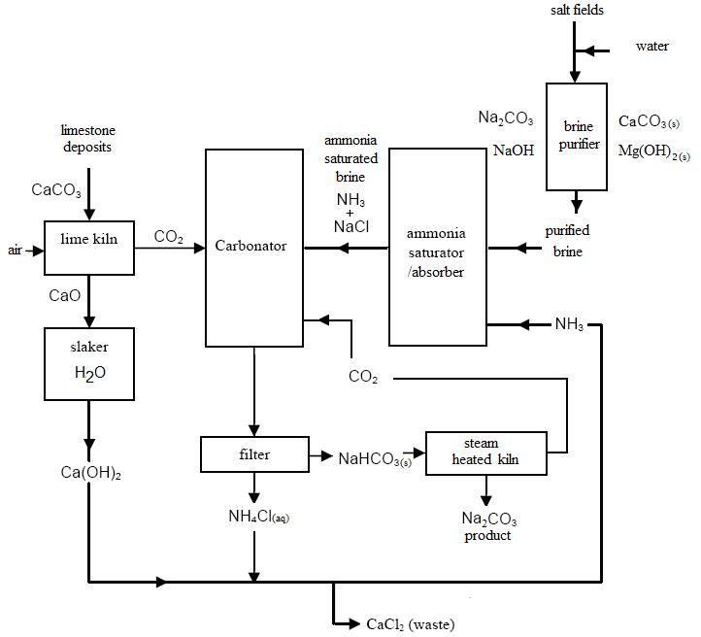**Interpreting Flowcharts**

The flowchart shows the process used to manufacture sodium carbonate (NaCO3) by the Solvay Process.

1. Name two **raw materials** used in this process. _____________________________________
2. Name the **product** from this process. ____________________________________________
3. Name the 3 chemicals that go into the carbonator.

___________________________________________________________________________

1. Name a waste product from this process. _________________________________________
2. Write a chemical equation for the reaction that occurs in the carbonator.
3. Complete the overall reaction that occurs in this flowchart.

CaCO3 + NaCl

1. Name a substance that is recycled in the process. ______________________________
2. Write an equation for the reaction in the heated kiln.
3. Suggest a possible source of the sodium chloride needed in this process. ________________

The flowchart below shows the materials used in the manufacture of the fertilisers ammonium nitrate [NH4NO3], and urea, [(NH2)2CO].

Air Carbon dioxide Water

NH3

Carbon dioxide purifier

Ammonia Plant

CO2

CO2

NH3

NH3

Nitric acid plant

Urea Plant

HNO3

Ammonium nitrate plant

ammonium nitrate urea excess carbon dioxide

1. List three raw materials that are needed to manufacture ammonium nitrate.

___________________________________________________________________________

1. Name one by-product of the process. ____________________________________________

Name one possible use of this by-product. ________________________________________

1. Name the two chemicals that combine to produce ammonium nitrate.

_________________________________________________________________

Write a balanced equation for the reaction.

1. Briefly describe one potential harmful effect that a leakage from this manufacturing plant could have on the local environment.