Stage 2 Chemistry
Organic and Biological Chemistry: Introduction

Science Understanding
- Organic compounds can be represented by molecular and structural formulae.
  - Determine the molecular formula of an organic compound given its extended, condensed, or skeletal structural formula.
- Organic compounds are named systematically to provide unambiguous identification.
- Condensation reactions occur when two organic molecules combine to form a larger molecule, also releasing another small molecule, such as water.
- The physical properties of organic compounds are influenced by the molar masses of the molecules, and the number and polarity of functional groups.
  - Predict, explain, and compare the melting points, boiling points, and solubilities in water and in non-polar solvents of organic compounds, given their structural formulae.

Term | Definition | Example
homologous series | A grouping of organic compounds based on their composition and properties.  A series has:  - a general formula,  - the same functional group,  - similar chemical properties,  - changing physical properties as molecular size changes.
functional group | Is the reactive site on a molecule.  It’s the group of atoms on the molecule responsible for its chemical properties.
saturated hydrocarbons | They are compounds of carbon and hydrogen only.  These compounds that contain only  single C – C bonds.  They are relatively unreactive.  They do not have a functional group.  Non polar
unsaturated hydrocarbons | They are compounds of carbon and hydrogen only.  These compounds have multiple carbon – carbon bonds, eg double or triple carbon bonds.  Homologous series are the alkenes alkynes and the aromatic compounds.
molecular formula | Shows the actual number of atoms present in the molecule.
structural formula | Shows the arrangement of atoms in the molecule – the way the atoms are bonded together in the compound
isomers | Compounds with the same molecular formula but different structural formula.

Determine the molecular formula of an organic compound given its extended, condensed, or skeletal structural formula.
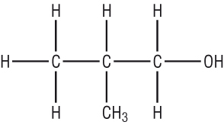
- Determine the molecular formula of the following compounds
  - _______________

  - _______________

  - CH₃CH₂COOH _______________
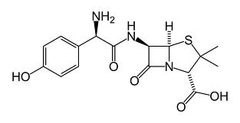
  - _______________

Systematically Naming Organic Compounds
There are three aspects of a compound that should be considered when naming. These are:
- The number of carbon atoms in the primary chain, the longest continuous chain.
- The functional group(s) in the compound.
- The branches, side-chains, off the primary chain.

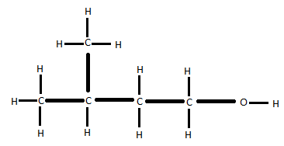

The Primary Carbon Chain
If the compound contains any functional groups, the primary chain is the longest carbon chain containing the functional group.
The length of the primary carbon chain has a corresponding name:
Number of carbons in the Primary Chain | Prefix
1 | Meth-
2 | Eth-
3 | Prop-
4 | But-
5 | Pent-
6 | Hex-
7 | Hept-
8 | Oct-

The Functional Group
If a functional group is present, a suffix is added to the name of the molecule.
Functional group | General Formula | Suffix added
Alkane |  | -ane
Alkene |  | -ene
Alkyne |  | -yne
Hydroxyl (alcohol) |  | -ol
Aldehyde |  | -al
Ketone |  | -one
Carboxyl (Carboxylic acid) |  | -oic acid
Amino (amine) |  | -amine

Side Chain Carbons
If a branch (side chain) is present, a prefix is added to the name of the molecule, with the suffix yl. It consists of two parts:
- a number indicating the position of the branch,
- and the name of the branch.
Number of carbons in the side chain | Name of side chain
1 | Methyl
2 | Ethyl
3 | Propyl

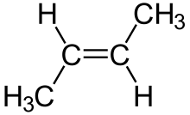
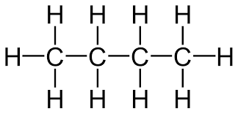
Name the following molecules
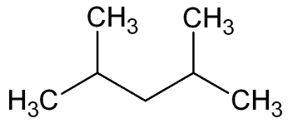

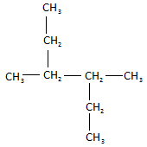
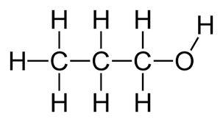
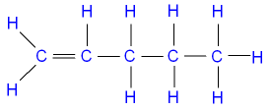

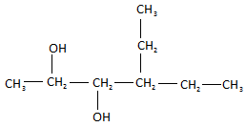
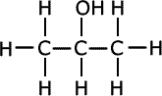

Draw the following molecules
- pentane

- 2-methyl-butane

- 2,3-dimethyl-3-ethyl-pentane

- 2,3dimethyl-but-2-ene

- 2,3-dimethyl-4-ethyl-hexan-2,3-diol
The physical properties of organic compounds are influenced by the molar masses of the molecules, and the number and polarity of functional groups.
Predict, explain, and compare the melting points, boiling points, and solubilities in water and in non-polar solvents of organic compounds, given their structural formulae.

Melting and Boiling Points
Melting and boiling points are determined by the strength of the intermolecular bonds.
Intermolecular bonds or secondary interactions can be broken down into two main categories, polar and non-polar.
The strength of the secondary interactions is the sum of both of these.
Boiling points of alkanes
Name | Molecular Formula | Condensed structural formula (of straight-chained isomers) | Molar mass | Boiling Point (⁰C)
methane | CH₄ | CH₄ | 16.04 | -164
ethane |  | CH₃CH₃ | 30.07 | -87
propane |  | CH₃CH₂CH₃ | 44.09 | -42
butane | C₄H₁₀ |  | 58.12 | 0
pentane |  | CH₃(CH₂)₃CH₃ | 72.15 | 36
hexane |  | CH₃(CH₂)₄CH₃ | 86.17 | 69
heptane | C₇H₁₆ | CH₃(CH₂)₅CH₃ | 100.20 | 98
octane |  | CH₃(CH₂)₆CH₃ | 114.22 | 126
nonane | C₉H₂₀ |  | 128.25 | 151
decane |  | CH₃(CH₂)₈CH₃ | 142.28 | 174

- Complete the above table
- Describe the trend between molar mass and boiling point
_________________________________________________________________________
- Alkanes are non-polar molecules, so the only secondary interactions are ________________

Boiling points of alcohols
Name | Structural Formula | Molar mass | Boiling point (⁰C)
methanol | CH₃OH | 32.04 | 65
ethanol | CH₃CH₂OH | 46.07 | 78
propanol | CH₃CH₂CH₂OH | 60.09 | 97
butanol |  | 74.12 | 117

- Is there a similar trend in boiling points observed here? ______________________________
- Compare methanol with ethane, which has a similar molecular mass. What do you notice about the boiling points?

Boiling Points of carboxylic acids
Name | Structural Formula | Molar mass | Boiling point (⁰C)
ethanoic acid | CH₃COOH | 60.05 | 117.9
propanoic acid | CH₃CH₂COOH | 74.08 | 141.1
butanoic acid | CH₃CH₂CH₂COOH | 88.10 | 163.7
pentanoic acid |  | 102.13 | 186.1

- Is there a similar trend in boiling points observed here? ______________________________
- Compare propanol with ethanoic acid, which has a similar molecular mass. What do you notice about the boiling points?

Aldehydes |  |  | Ketones
Name | Structural Formula | Boiling point (⁰C) | Name | Structural Formula | Boiling point (⁰C)
methanal | HCHO | -19.1
ethanal | CH₃CHO | 20.1
propanal | CH₃CH₂CHO | 48 | propanone |  | 56
butanal | CH₃CH₂CH₂CHO | 74.8 | butanone |  | 79

- Why are methanone and ethanone not included in the table?
- Given that, for the same size carbon chain, the molar masses of the aldehydes and ketones are very much the same as their alcohol equivalent, describe how the boiling points/melting points of alcohols compare with the aldehydes and ketones.
Summary
The boiling point of an organic compound depends on the __________________________________
__________________________________________________________________________________

These can be broken down into two categories, ________________ and _______________________

Non polar interactions are present between __________________ compounds.
They can be increased by _____________________________________________________________

Polar interactions are present between ______________________ compounds.
They can be increased by _____________________________________________________________
and ______________________________________________________________________________

Functional Group Polarity
Non-polar | Polar | Hydrogen bonds

Fill in the above table with all the functional groups listed on page four plus esters.

- State the two main chemical factors that will determine the melting and boiling point of an organic compound.
___________________________________________________________________________
- Explain which of the following compounds will have the highest boiling point:
C₂H₄, C₃H₆, C₄H₈, C₅H₁₀.

- Propanoic acid has the molecular formula C₃H₆O₂
  - Draw the structural formula for propanoic acid

  - On your diagram indicate the polarity of the functional group by indicating the dipoles.
  - Is propanoic acid able to display hydrogen bonding? ______________________
  - Draw the structural formula of an ester with the same molecular formula as propanoic acid.

  - Would you expect this ester to have a higher or lower boiling point than propanoic acid? Explain your answer
____________________________________________________________________
____________________________________________________________________
____________________________________________________________________
- For each group of compounds circle the one with the highest boiling point.
  - butanol, butanal, butanone
  - ethyl ethanoate and butanoic acid
  - pentane, butane, hexane and octane
  - propanol, butanol, hexanol, and ethanol
  - propanol, ethanoic acid, propanone and propanal
- An organic compound has the molecular formula C₄H₈O₂.
  - Name and draw the structural formula of the straight-chained carboxylic acid with this molecular formula.

  - Name and draw the two esters with this molecular formula.

  - State the chemical term used to describe these three compounds.

  - Predict and explain which compound, the carboxylic acid or one of the two esters, would have the highest boiling point.

- Carefully examine the data in the table below:
 | Molar mass | Boiling point (⁰C)
ethanol | 46.02 | 78
ethanal | 44.05 | 20.1
Explain the difference in boiling points of these two compounds

- Predict with reasons, which of the following pairs of organic compounds would have the highest boiling point
  - CH₃(CH₂)₇CH=CH(CH₂)₇COOH and CH₃(CH₂)₁₃CH=CH(CH₂)₁₃COOH

CH₃CH₂
CH₃
O
CH₃CH₂
CH₃
OH
  - and

The physical properties of organic compounds are influenced by the molar masses of the molecules, and the number and polarity of functional groups.
Predict, explain, and compare the melting points, boiling points, and solubilities in water and in non-polar solvents of organic compounds, given their structural formulae.
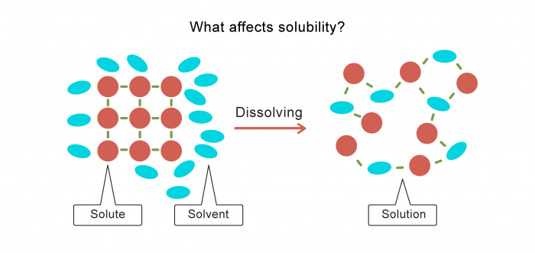
For a substance to dissolve there must be a force of attraction between the solvent and solute that is strong enough to disturb the intermolecular forces in both the solvent and solute

The closer in strength that the intermolecular forces are between solute and solvent, the more likely they are to be soluble.

Like boiling point, the solubility of compounds is affected by two variables:
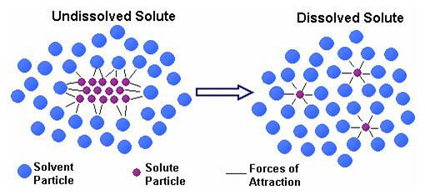
________________________________
________________________________

Solubility in water _________________________ as chain length increases
Solubility in water _________________________ as polarity increases

Solubility in non-polar solvents will have the opposite relationship with polarity

- State the two characteristics of an organic compound that would contribute to it being insoluble in water.
___________________________________________________________________________
___________________________________________________________________________
___________________________________________________________________________

- Petrol is a complex mixture of hydrocarbons with the main constituent being octane, C₈H₁₈.
  - Is octane a non-polar or a polar molecule? _________________________________
  - Would you expect octane to be soluble in water? ____________________________
  - What type of solvent will dissolve octane? _________________________________
  - Describe why octane is able to dissolve in these types of solvents.
___________________________________________________________________________
___________________________________________________________________________

  - Draw the structural formula for a molecule of pentan-2-ol.

  - On your diagram indicate the polarity of the functional group by drawing the dipoles.
  - Is pentan-2-ol able to display hydrogen bonding? ______________________
  - Add a water molecule to your diagram and show the hydrogen bonding between water and pentan-2-ol.
  - Explain whether you would expect hexan-2-ol to be soluble in water?
__________________________________________________________________
__________________________________________________________________
__________________________________________________________________

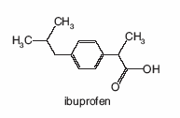
- The following diagram shows the structural formulae for ibuprofen and acetaminophen, two pain-relieving drugs, similar to aspirin.

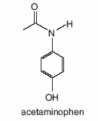

Briefly explain which of these two drugs would be more soluble in water. [Assume the molar masses of both molecules are similar.]
__________________________________________________________________________________
__________________________________________________________________________________
__________________________________________________________________________________
__________________________________________________________________________________

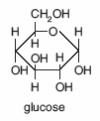
- Large organic molecules are usually insoluble in water. However glucose, whose structure is shown opposite, is very soluble in water.
  - Write the molecular formula for glucose.
_________________________________
  - Explain why glucose has such a high solubility in water.
___________________________________________________________________________
___________________________________________________________________________
___________________________________________________________________________
___________________________________________________________________________

