- Canola oil is used in cooking. During the cooking process some of the triolein undergoes hydrolysis. One sample of canola oil was tested after use in cooking and found to have a pH of 5.5.
  - Calculate the concentration, in mol L^{–1} , of H⁺ in this sample.

(2 marks)

- The concentration of amine chloride salts in a 50 L sample of water from another metal pipe is 5 ppm. Calculate the mass, in grams, of amine chloride salts in this sample.

(2 marks)
- Volumetric analysis is used for the quantitative determination of PbCO₃ in mineral ores. A 3.15 g sample of an ore was analysed to determine the percentage of PbCO₃ present, using the following procedure:
Step 1 An excess of 0.6293 mol L^{–1} HNO_{3(aq)} was added to the sample. The equation for this reaction is shown below:
2HNO_{3(aq)} + PbCO_{3(s)} -> Pb(NO₃)_{2(aq)} + H₂O_{(l)} + CO_{2(g)}
Step 2 When the reaction was complete, the unreacted HNO₃ was titrated with 0.1423 mol L^{–1} NaOH_{(aq)}. The equation for the titration reaction is shown below:
HNO_{3(aq)} + NaOH_{(aq)} -> NaNO_{3(aq)} + H₂O_{(l)}
- State one observation that would indicate that the reaction in Step 1 was complete.
________________________________________________________________________
(1 mark)
- Credit will be given for the correct use of significant figures in answers to part (b). (1 mark)
  - The volume of HNO₃ added in Step 1 was 25.00 mL. Calculate the number of moles of HNO₃ added to the sample.

(2 marks)
  - The volume of NaOH required was 23.67 mL. Calculate the number of moles of NaOH that reacted with the HNO₃ in Step 2.

(2 marks)
  - Calculate the number of moles of unreacted HNO₃ that remained after Step 1.

(1 mark)
  - Hence, calculate the number of moles of HNO₃ that reacted during Step 1.

(1 mark)
  - Calculate the number of moles of PbCO₃ in the ore sample.

(2 marks)
  - Calculate the percentage, by mass, of PbCO₃ in the ore sample.

(3 marks)
  - The ore analysed also contained CaCO₃. State and explain the effect of CaCO₃ on the calculated percentage of PbCO₃ in the ore sample. ______________________________________________________________________________________________________________________________________________________________________________________________________________________________________________________________________________________________________________________________________________________________________________________________________
(3 marks) TOTAL: 16 marks

- An ore sample containing bismuth was analysed using atomic absorption spectroscopy (AAS).
Standard solutions of bismuth were used to calibrate the spectrometer and the following data were recorded:
Bismuth concentration (ppm) Absorbance
0.0 0.00
5.0 0.25
10.0 0.56
15.0 0.81
20.0 1.08

- Using the data in the table on the page opposite, plot a calibration line

(5 marks)
- State the characteristic of a calibration graph that provides information about the precision of the results obtained.

____________________________________________________________________________________________ (1 mark)

- The absorbance of the sample containing bismuth was found to be 0.51.
Determine the concentration, in ppm, of bismuth in the sample.

____________________________________________________________________________________________ (1 mark)

- Explain why other trace elements in the sample containing bismuth will not interfere with the AAS analysis of bismuth.

__________________________________________________________________________________________
__________________________________________________________________________________________
__________________________________________________________________________________________
_________________________________________________________________________________________
__________________________________________________________________________________________
__________________________________________________________________________________________ (3 marks)

- Credit will be given for the correct use of significant figures in answers to part (c). (1 mark)
- A sample of white wine was treated to ensure all of the sulfur present was in the form of SO2. The
SO2 concentration was then determined by titration. In one titration procedure, white wine was pipetted into a conical flask and titrated with an iodine solution.

(i) State which one of the following should have been used to rinse the conical flask immediately
before use: iodine solution, white wine, or distilled water.

____________________________________________________________________________________________ (1 mark)

(ii) In one 20.0 mL sample of white wine, the SO2 concentration was calculated to be 4.76 x10^{–3} mol L^{–1}.
Calculate the volume of 0.0120 mol L^{–1} iodine solution that would have reacted in this titration, given that the equation for the reaction is:

(4 marks)
(iii) Determine whether the SO2 concentration of 4.76 ξ10^{–3} mol L^{–1} in this sample was lower than the Australian legal limit of 250 mg L^{–1} for wine.

(3 marks)

- Lindane has been used in mosquito control, and is therefore present in the environment. It has been estimated that the daily human intake is approximately 14 ng per kilogram of body weight.
Calculate in μg the daily intake of lindane for a 70 kg person.

  - The presence of lindane and other pesticides can be detected using chromatography.
- Explain the principles of chromatography.

______________________________________________________________________________________________________
______________________________________________________________________________________________________
______________________________________________________________________________________________________
______________________________________________________________________________________________________
______________________________________________________________________________________________________
______________________________________________________________________________________________________
______________________________________________________________________________________________________
___________________________________________________________________________________________ (4 marks)

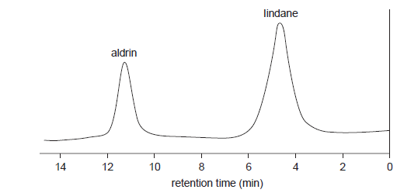
- An analysis for the pesticides lindane and aldrin was undertaken using gas chromatography in which the column used was packed with a non-polar form of silica. The following chromatogram was obtained:

- State the retention time for lindane.

________________________________________________________________________________________ (1 mark)

- State whether aldrin is more polar or less polar than lindane.

________________________________________________________________________________________ (1 mark)

- Thin-layer chromatography using a polar stationary phase was used to identify the two vanilloids vanillin and eugenol. The diagram below shows the chromatogram produced:
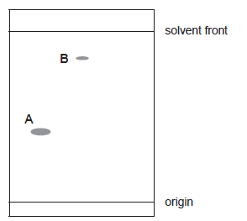

- Calculate the RF value for B.

- Aluminium is the most common metal in the Earth’s crust.
  - Aluminium toxicity to plants affects some wheat-growing regions of Australia. In the pH range
4.0–6.0 aluminium is present in soil as three species in equilibrium:
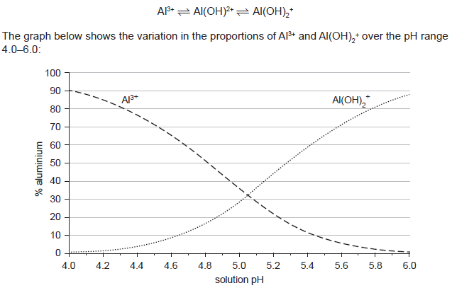

  - State what happens to the percentage of aluminium present as Al(OH)2 as pH increases
from 4.0 to 6.0.

______________________________________________________________________________________________________

____________________________________________________________________________________________ (1 mark)

  - Using the graph above, determine the pH when 65% of the aluminium is present as Al3+.

____________________________________________________________________________________________ (1 mark)

  - The graph does not show the percentage of aluminium present as Al(OH)²⁺ across the pH
range 4.0–6.0. Using the graph above, determine the percentage of aluminium present as Al(OH)²⁺ at pH 5.5. Show your working.

  - A wheat farmer found that the total concentration of aluminium in a soil was 43 μmol L^{–1}.
    - Using the graph on the page opposite, determine the concentration, in μmol L^{–1}, of Al³⁺ in this soil if it has a pH of 4.2.

(2 marks)

