Stage 2 Chemistry
Organic and Biological Chemistry: Aldehydes and Ketones

Science Understanding
- Aldehydes and ketones are produced by the oxidation of the corresponding primary and secondary alcohols respectively.
- Identify, name systematically, and draw structural formulae of aldehydes and ketones containing:
  - up to eight carbon atoms in the main chain, with side chains limited to a maximum of two carbon atoms
  - one or more aldehyde or ketone groups.
- Aldehydes can be readily oxidised; ketones cannot.
  - Draw the structural formula of the oxidation product of a given aldehyde in either acidic or alkaline conditions.
- Describe how acidified dichromate solution and Tollens’ reagent (ammoniacal silver nitrate solution) can be used to distinguish between aldehydes and ketones.

Aldehydes
Aldehydes can be prepared from the controlled oxidation of a primary alcohol. The oxidation must be carefully controlled because aldehydes are easily oxidised to carboxylic acids.
Aldehydes are prepared using distillation apparatus, with a separating funnel used to provide controlled oxidation of the alcohol. The oxidising agent, dichromate ions, is added drop by drop into a heated primary alcohol and acid mixture. The alcohol is oxidised to the aldehyde which immediately boils off before it is further oxidised to the carboxylic acid.

- Explain why the aldehyde will boil off from the mixture of alcohol, aldehyde and carboxylic acid.

- Write the name of the aldehyde prepared from the following alcohols
  - Propan-1-ol ________________________________
  - Hexan-1-ol ________________________________
  - 2,3-dimethyl-butan-1-ol ________________________________

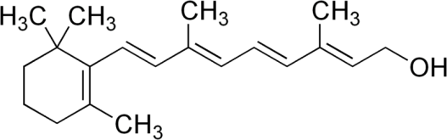
- Draw the aldehyde produced from retinol

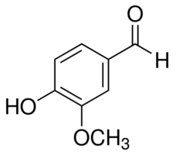
- Draw the alcohol that produced vanillin

Ketones
Ketones are prepared from the oxidation of ___________________________________________
They do not oxidise further so they do not have to be distilled as they form.
Oxidation of aldehydes
When aldehydes are heated with an acidified solution of dichromate ions, they undergo oxidation to carboxylic acids.
RCHO RCOOH
Cr₂O₇²⁻ Cr³⁺

Aldehydes can also undergo oxidation when heated with ammoniacal silver nitrate, commonly called Tollen’s reagent.
Tollen’s reagent is a silver diamine ion that reduces to _____________________________________
Tollen’s reagent is used as a test for the presence of aldehydes
The observation that accompanies a positive test is ________________________________________

Tollen’s reagent is used under alkaline conditions; therefore the product is a ___________________ not a carboxylic acid.
Tollen’s reagent is a weak oxidising agent, so does not oxidise alcohol functional groups.

- Draw the reaction product of propanal being oxidised by
  - Dichromate ions

  - Tollen’s reagent

- Describe what reagents you could use to distinguish between propanol, propanal and propanone. Include the observations that would guide your decision.

- State whether the following compounds are aldehydes, ketones, both or neither.
  - CH₃CH₂CHO _______________________
  - CH₃CH₂COOCH₂CH₃ _______________________
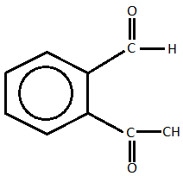
  - CH₃CH₂COOH _______________________

_______________________

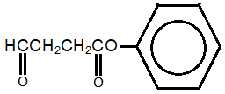

  - Name the alcohol that would be oxidised by acidified dichromate solution to prepare butanal.
______________________________________
  - Name the other product that could be formed if the oxidation reaction was allowed to continue.
___________________________________________
  - State the reaction conditions that would be used in the preparation of butanal that would prevent the formation of the compound named in part b.
_____________________________________________________________________
_____________________________________________________________________
  - Draw the structural formula and name the alcohol that would be oxidised by acidified dichromate solution to prepare butanone.

  - Explain why the conditions that were necessary for the preparation of butanal would not be needed for the preparation of butanone.
_____________________________________________________________________
_____________________________________________________________________
- An organic compound, C₃H₆O, was mixed with ammoniacal silver nitrate solution in a test tube.
A silver mirror was formed on the inside wall of the test tube.
  - State the common name for ammoniacal silver nitrate solution.
____________________________________________
  - Write the structural formula of the organic compound C₃H₆O and give its systematic name.

  - Name and write the structural formula of the product formed from C₃H₆O in the reaction.

  - Ammoniacal silver nitrate solution contains silver ions Ag⁺, which are converted to silver. Write the half-equation for this reaction.

