Stage 2 Chemistry
Monitoring the Environment: Atomic Adsorption Spectroscopy

Science Understanding
- Flame tests and atomic absorption spectroscopy (AAS) are analytical techniques that can be used to identify elements; these methods rely on electron transfer between atomic energy levels.
  - Write the electron configuration using subshell notation of an atom of any of the first 38 elements in the periodic table.
  - Explain the effect of the absorption or emission of radiation on the electron configuration of electrons in atoms or ions.
- The wavelengths of radiation emitted and absorbed by an element are unique to that element and can be used to identify its presence in a sample.
  - Explain why some wavelengths of radiation emitted and absorbed by an element are unique to that element.
- Atomic absorption spectroscopy is used for quantitative analysis.
  - Explain the principles of atomic absorption spectroscopy in identifying elements in a sample.
  - Describe the construction and use of calibration graphs in determining the concentration of an element in a sample.

Electron Configuration Review
- There are energy levels within the main energy levels in which electrons exist, and these are called sub-shells.
- The sub-shells are labelled s, p, d, and f, and each sub-shell contains a maximum number of electrons:
______ electrons in s
______ electrons in p
______ electrons in d
______ electrons in f.
- The name of a sub-shell begins with the number of the main energy level, and then the letter of the sub-shell. Then a small number written like a power may appear which describes the number of electrons in the sub-shell.

eg 2p⁴ means the p sub-shell in the second energy level containing 4 electrons

- It is essential that you know the energy sequence of the sub-shells and the maximum number of electrons that can exist in each sub-shell.
This is necessary to work out the electronic configuration of an atom.
- The energy sequence of sub-shells reveals that there is an overlap of some energy levels. In particular, you need to be aware that the 4s sub-shell is of a lower energy than the 3d sub-shell.

6s | 6p | 6d | 6f
5s | 5p | 5d | 5f
4s | 4p | 4d | 4f
3s | 3p | 3d
2s | 2p
1s

Write the electronic configuration for the following atoms
O ____________________________________________
Mn ____________________________________________
S ____________________________________________
- Elements with atomic number 21 – 30 form the first row transition elements. They are called the 3d-transition elements because they are a result of the filling of the 3d sub-shell. There are two exceptions to the order in which the sub-shells are filled for the transition elements.
You will need to know that the two exceptions are copper and chromium.
Cr ____________________________________________
Cu ____________________________________________

Explanation ____________________________________________________________________
____________________________________________________________________

- The electronic configuration for ions is calculated by first obtaining the electronic configuration of the atom and then:
- either adding electrons equal to the charge of the ion if it is a negative ion,
- or subtracting electrons equal to the charge of the ion if it is a positive ion.

Li⁺ _____________________________________________
Ca²⁺ _____________________________________________
Cl⁻ _____________________________________________

- When transition metals form ions, the 4s electrons are always lost first.

Fe²⁺ _____________________________________
Fe³⁺ _____________________________________
Zn²⁺ _____________________________________

Explanation ________________________________________________________
________________________________________________________

- The electronic configuration of the Noble Gas elements is a stable configuration of filled sub-shells.

Ar _______________________________________

Electron configuration and absorption of energy

Electrons exist in finite energy levels. The electronic configuration gives us the position of electrons in their ________________________. This is their most stable configuration and is achieved at room temperature.
An electron can absorb energy to move to a more excited state. They can do this in two ways:
Absorb heat:
Absorb light:

Electrons are not stable in this excited state and quickly drop down, emitting a ________________ with the same energy as the corresponding energy gap between energy levels. As this is a specific amount of energy, it will have a specific wavelength and hence colour.

Flame Tests

A simple qualitative test for metals is a flame test.
Eg A solution of the metal salt is sprayed as a fine mist into a flame.
Na – yellow, K – lilac, Ca – brick red.

The same will happen when metal vapours are subjected to a high voltage in metal vapour lamps.
Eg sodium street lights are yellow.
This emission of light is called an emission spectrum.

Explanation?
It can be explained in terms of the energy levels of electrons in the metal atoms or ions.
Electrons exist in a finite number of specific energy levels.
Eg Na – 1s² 2s² 2p⁶ 3s¹.
This is the ground state electron configuration for sodium.
How is this related to AAS?
AAS involves:
The absorption of electromagnetic radiation (EMR) of certain wavelengths by atoms in a sample being analysed.
A spectrophotometer measures the intensity of the radiation transmitted through the sample relative to the intensity entering the sample.

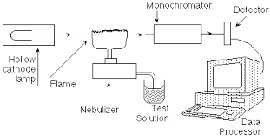
The main components of an atomic absorption spectrometer are:

A source of radiation:
A cathode lamp containing the same metal as that being analysed in the sample.
It emits radiation (light) of certain frequencies (wavelengths) which correspond to the energy gaps characteristic of the metal in the sample.

A system to place the sample in the radiation path:
The radiation (light) is directed through a flame into which the sample is sprayed.
Any atoms of the metal the same as that in the lamp will absorb the radiation emitted. The absorbance is proportional to the concentration of the metal in the sample.

A monochromator to select the radiation to pass through a detector:
This selects the absorption frequencies for the metal in the sample.
This is passed onto a detector that measures the intensity as an absorbance value.

Uses of AAS
metal ions in drinking water, milk, blood, urine and wine, metal ions in effluent from industrial plants

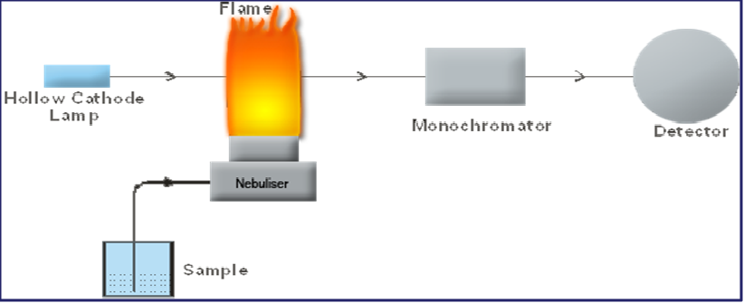

SUPPORTING QUESTION SET 1
- Write out what the letters AAS stand for. ________________________________________
  - Is AAS a qualitative or quantitative analytical technique? ______________________
  - State one common use of AAS.
____________________________________________________________________
  - List the three main components of an atomic absorption spectrometer.
_____________________________________________________________________
_____________________________________________________________________
_____________________________________________________________________
  - State the purpose of each of these components.
    - ______________________________________________________________
    - ______________________________________________________________
    - _____________________________________________________________

- Describe the principle upon which AAS works.
___________________________________________________________________________
___________________________________________________________________________
___________________________________________________________________________
___________________________________________________________________________
- Explain why solutions of known concentrations are analysed first.
___________________________________________________________________________
___________________________________________________________________________
- A breakfast cereal claims to contain 4 mg of potassium. If AAS was used to check this claim, what kind of filament would have to be placed in the cathode lamp?
__________________________________________________________________
- A sample of oysters was tested using AAS for the presence of mercury. The sample was found to contain mercury in a concentration of 3.05 x 10⁻⁷ mol L⁻¹. Convert this to a concentration in ppb.

Atomic Absorption Spectroscopy - an example calculation
- The percentage of chromium in a sample of steel was determined using atomic absorption spectroscopy. The following absorbance readings (for a selected wavelength) were obtained from a series of standard solutions of Cr³⁺ ions.

Concentration of Cr³⁺ ions (ppm) | Absorbance
2.0 | 0.062
4.0 | 0.124
6.0 | 0.186
8.0 | 0.240
10.0 | 0.300

- Use the figures in the table above to plot a calibration curve, absorbance against the concentration of Cr³⁺ ions.

- A 250 mg sample of steel was dissolved in a hot concentrated solution of hydrochloric acid, producing a solution of Cr3+ ions.
The resulting solution was transferred to a volumetric flask and diluted to 500 mL with water. A sample of this diluted solution gave an absorbance reading of 0.265.
Use the calibration curve to determine the concentration of Cr³⁺ ions (in mg L⁻¹) in the diluted sample.

- From the value obtained in part b), calculate the mass (in mg) of chromium in the 250 mg sample of steel.

- Hence calculate the percentage of chromium in the steel.

- When the steel is dissolved in the hydrochloric acid, Fe³⁺ ions are also produced.
  - Write an ionic equation for the reaction that produces these Fe³⁺ ions.

  - Explain why these Fe³⁺ ions do not interfere with the absorbance of the wavelength of radiation selected for the chromium.
_____________________________________________________________________
_____________________________________________________________________
_____________________________________________________________________
  - Suppose the chemist wished to analyse this sample of steel for its iron content. What component of the atomic absorbance spectrometer would the chemist change so that this analysis could be performed?
____________________________________________________________________
____________________________________________________________________
  - AAS is used mainly as a quantitative analytical technique. Explain the meaning of this term.
____________________________________________________________________
____________________________________________________________________

