Stage 2 Chemistry

Birdwood
HIGH SCHOOL Topic 4: Organic and Biological Chemistry
Systematic nomenclature and Physical properties
Review Paper 9
DUE DATE: Ref: ESSENTIALS pages 235 - 253

Question 1

a Define the term structural isomers.
Same molecular formula, different structural formula
b Draw and name one ester and one carboxylic acid with molecular formula: C₃H₆O₂. (6 marks)
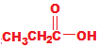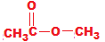

Propanoic acid methyl ethanoate
Question 2

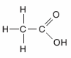
State the systematic names of the following organic molecules.

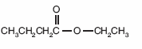
a HOCH₂CHCH₃ b c

CH₃
2-methyl-propan-1-ol ethyl butanoate ethanoic acid

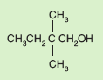
CH₃
d e f

CH₃ CH CH₂ C OH

O
3-methyl-butanoic acid 2,2-dimethyl-butan-1-ol 3-methyl-hexane
g H h i
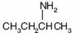
O
H C C
H
H (9 marks)
ethanal butan-2-amine ethan-1,2-diol

Question 3

Draw structural formulae for the following organic compounds or ions:

a 2,3-dimethyl -3- ethylpentane
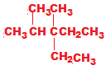

b 4-chloro -3,3 - dimethylbut-1-ene
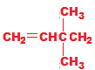
c 2-methylpropan -2- ol
d hexan -3- one
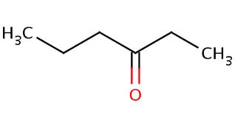
e 4-methylpentanal
f methyl propanoate
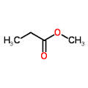
g a butanoate ion (formed when butanoic acid loses its acidic hydrogen)
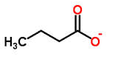
h 1-butanamine

(8 marks)
Question 4

The table below shows three members of the amine family of organic compounds.
The boiling point of each member of the amine family is shown.

Name | Structural Formula | Boiling Point (⁰C)
methanamine | CH₃NH₂ | -8
ethanamine | CH₃CH₂NH₂ | 20
propanamine | CH₃CH₂CH₂NH₂ | 50

a. Complete the table by filling in the appropriate missing name and structural formula.

b. Describe the trend observed in the boiling points of the amines shown.
As the chain length increases, so does the boiling point (3 marks)

Question 5

A solution of sulfuric acid is analysed to determine its concentration using volumetric analysis.

20.00 mL of 0.135 mol L⁻¹ sodium hydroxide is added to a conical flask. A suitable indicator is added and the sulfuric acid is then added until the end-point is reached. The average titre required to reach the end-point was 15.39 mL.

a. Name the most suitable piece of apparatus used to deliver the sulfuric acid.
Burette
b. With what should the conical flask be rinsed?
Distilled water
c. Write an equation for the reaction occurring in the conical flask, given that one of the products is sodium sufate Na₂SO₄.
2NaOH + H₂SO₄ - > Na₂SO₄ + H₂O
d. Calculate the number of moles of sodium hydroxide added to the conical flask.
n = C V
n = 0.135 x 0.02
n = 0.0027 mol
e. Use the reacting mole ratio to calculate the number of moles of sulfuric acid that reacted with the sodium hydroxide.
H₂SO₄ / NaOH = 1 / 2
n(H₂SO₄) = 0.0027 / 2
n(H₂SO₄) = 0.00135
f. Hence, calculate the concentration of the sulfuric acid in mol L⁻¹.
C = n / V
C = 0.00135 / 0.01539
C = 0.0877 mol L⁻¹
g. Convert this concentration to %w/v.
0.0877 x (2 x 1.008 + 32.07 + 4 x 16) = 8.60 g L-1
8.60 / 10 = 0.860 %w/v (9 marks)

Question 6

a The concentration of chloride ions in a swimming pool is 2.5 x 10⁻⁵ mol L⁻¹.
Convert this concentration to μg mL⁻¹.
0.000025 mol L⁻¹ x 35.45 = 0.000886 g L⁻¹
0.000886g L⁻¹ = 886μg L⁻¹
886μg L⁻¹ = 0.886μg mL⁻¹

b Tablets, that contain sodium fluoride, NaF, can be purchased and used to add F⁻ ions to drinking water in
order to reduce tooth decay.

A brand of tablet contains 0.8 mg of F⁻ per tablet.
Calculate the minimum number of these whole tablets that must be dissolved in 10 L of water to achieve a
concentration of at least 0.95 mg L⁻¹.
m = C V
m = 0.95 x 10
m = 9.5mg
9.5 / 0.8 = 11.875 tablets
12 tablets required to reach desired concentration
(5 marks)

TOTAL MARK = 40

