## **Stage 2 Chemistry**

## **Birdwood**

HIGH SCHOOL **Topic 5: Materials**

**Polymers, and Silicate Structures**

**Review Paper 18 and properties**

**DUE DATE:** Ref: ESSENTIALS pages 309 - 323

1 Part of the polymer chain of the substance Kevlar is shown below:

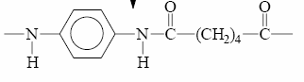

(6 marks)

i Identify the amide link in the section shown.

ii State the name of the polymerization that was used to make Kevlar.

Condensation

iii Name the other product formed during this polymerization reaction.

Water

iv State the type of bonds that would be found between adjacent chains of Kevlar. (4 marks)

Hydrogen bonds

2 The monomer used to make the polymer Perspex has the structural formula drawn below.

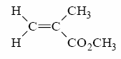

i Write the *molecular formula* of the monomer from which Perspex would be made.

C5H8O2

ii Identify the *two* functional groups present in the monomer of Perspex.

Alkene and ester

iii What kind of polymerization would you expect this monomer to undergo?

Addition

iv When the monomer of Perspex is heated under reflux with NaOH(aq), a carboxylate salt and an

alcohol form.

Write a balanced equation for this reaction.

C5H8O2  + NaOH -> CH2C(CH3)COO-Na+ + CH3OH

v Perspex is a thermoplastic. Describe *two* physical properties that you would

expect Perspex to have. (8 marks)

will soften when heated and some degree of flexibility and elasticity

3 i Olivine, a green mineral, has the formula MgFe(II)SiO4. [Fe(II) means Fe2+]

Calculate the charge on the silicate ion in olivine.

+2+2 = +4, therefore the silicate has a charge of -4

ii The mineral chlorite has the formula, AlMg5AlSi3O10 (OH)8.

* 1. Chlorite is classified as an aluminosilicate. Describe how aluminosilicates form.

Aluminosilicates form when aluminium replaces silicon in the silicate lattice.

* 1. Write the formula of the aluminosilicate in chlorite?

AlSi3O105-

* 1. What *fraction* of the silicon atoms in the original silicate have been replaced by aluminium in chlorite?

1 in 4, ¼

iii Nepheline with the formula NaAlSiO4, is a hard crystalline mineral.

* + 1. Draw the structural formula for the silicate mineral found in nepheline.

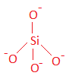

* + 1. Name the shape of this silicate anion. tetrahedral

iv An aluminosilicate clay found in soil has the formula KAl5Si7Ox(OH)4.

Determine the value of x in the formula of the clay. (8 marks)

+1 + 5x3 + 4x7 – 2xX – 4x1 = 0

+1 + 15 + 28 -2X – 4 = 0

-2X = -40

X = 10

4 Starch can be used as a raw material for the production of industrial solvents.

The first step in the production is the hydrolysis of starch to form glucose.

The structural formula of a section of starch is shown below:

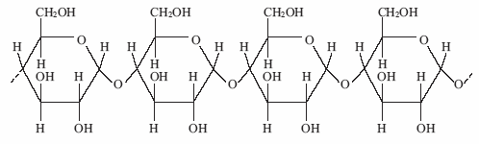

i Describe what is meant by the term *hard water*.

ii Calculate the charge on the aluminosilicate in this zeolite.

iii Explain how the zeolite with the formula Na2 (Al2Si3O10).2H2O is able to remove

hardness from water. (7 marks)

i Draw the structural formula of a glucose monomer produced from starch.

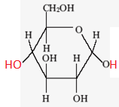

ii The conversion of starch into glucose occurs by enzyme-catalysed hydrolysis.

Write an equation for the conversion of starch into glucose. (4 marks)

(C6H10O5)n + nH2O -> nC6H12O6

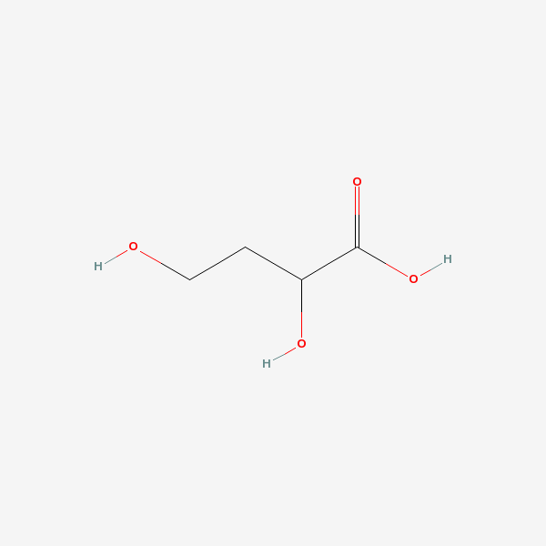5 2,4 – dihydroxybutanoic acid can be

used as a monomer to form a polymer.

i On the diagram opposite, circle

the secondary alcohol.

ii Draw a section of the polymer

formed when two

2,4 – dihydroxybutanoic acid

monomers join.

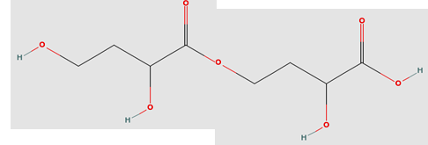

iii State the type of polymerization

that would produce this polymer.

Condensation (esterification)

iv The polymer formed is able to

make relatively strong bonds

between the chains.

Describe two properties this would

give the polymer.

Elasticity, rigidity

(6 marks)

**TOTAL MARK = 35**