Stage 2 Chemistry

Birdwood
HIGH SCHOOL Topic 4: Organic & Biological Chemistry
Carboxylic acids, Esters, Triglycerides
Review Paper 12
DUE DATE: Ref: ESSENTIALS pages 261 - 292

Question 1 (8 marks)

Simple esters can be found in most foods and drinks. The structural formula of one such ester is shown below:

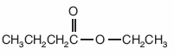

- State the common odour associated with most ester compounds.
Fruity
- Draw the structural formula of the functional group in the ester shown above.
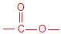
- State the systematic name of the ester shown above.
Ethyl butanoate
- State the systematic names of the alcohol and the carboxylic acid from which this ester is derived.
Ethanol and Butanoic acid
- The diagram below shows the apparatus used in the initial preparation of a typical ester.

  - What special name is given to the way this apparatus is set up?
Reflux
  - State the two main reasons why this set up is
used in the preparation of an ester?
Allows for extended heating without loss of products

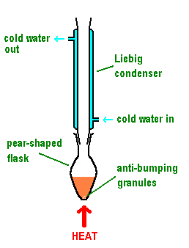

Question 2

Banana flavouring in milkshakes and icecreams can be obtained using the substance:

CH₃COO(CH₂)₄CH₃

a) Write the systematic name of this compound.
Pentyl ethanoate
b) Write a balanced equation for the alkaline hydrolysis of this compound.
CH₃COO(CH₂)₄CH₃ + ⁻OH -> CH₃COO⁻ + CH₃CH₂CH₂CH₂CH₂OH (4 marks)
Question 3

The fragrance of raspberries is due mainly to the presence of the ester ethyl methanoate.

- Write the name of the acid from which this ester could be prepared.
Methanoic acid
b) Draw the structural formula of ethyl methanoate.
CH₃CH₂OOCH
c) To prepare the ester in the laboratory requires reacting a carboxylic acid with an alcohol in the presence of a
small amount of concentrated sulfuric acid.

i Write a balanced equation for the preparation of ethyl methanoate.
HCOOH + CH₃CH₂OH <-> CH₃CH₂OOCH + H₂O
ii State one of the functions of the sulfuric acid. (7 marks)
acid catalyst for the reaction
mild dehydrating agent which helps to drive equilibrium towards products

Question 4

Olive oil is a popular cooking oil used in many countries around the world. The structure of palmitoleic acid, a fatty acid found in olive oil is shown below:

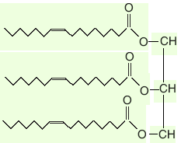

i Write the molecular formula for palmitoleic acid.
C₁₆H₃₀O₂

ii Draw the structural formula of the molecule of the triglyceride formed exclusively from palmitoleic acid and
propane-1,2,3-triol.

iii Describe how the structure of this oil suggests that this triglyceride is derived from plants and not animals.
Palmitoleic acid has a double bond, meaning the triglyceride formed from it will be unsaturated. Unsaturated triglycerides are generally derived from plants rather than animals.
iv Name the reagent and describe the conditions required to convert an oil such as olive oil into a higher melting point “margarine”.
Reagent is hydrogen (H₂).
High temperature, high pressure and a metal catalyst (Ni) are required
(7 marks)

Question 5

Many analgesics (pain relieving drugs) contain aspirin. The structure of aspirin is shown below.

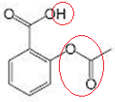

- Circle the ester functional group found in aspirin.

- Circle the acidic hydrogen on the functional group that gives aspirin acidic properties.

- If aspirin was used in the molecular form above, it would be ineffective because it is relatively insoluble. To be effective, aspirin must be in a soluble form.

i Describe the section of the structural formula of aspirin that makes it insoluble in water?
The large non-polar benzene functional group reduces the solubility in water.
ii Aspirin is sold in solid form, mixed with a base, eg NaHCO₃. This greatly increases the effectiveness of aspirin. Use the “acidic” part on the aspirin molecule to describe how the addition of a base can change aspirin into a soluble form.

The acidic carboxyl group will react with the basic NaHCO₃ to form a carboxylate salt. This carboxylate salt has a full negative charge and so can form the strong ion-dipole secondary interactions with water, leading to increased solubility. (6 marks)

Question 6

Ice-creams and milkshakes also contain a variety of solids dissolved or suspended in water. One type of solid dissolved is sugars such as glucose and sucrose.
Sucrose is a sugar found in sugar cane plants. It is formed when glucose combines with fructose.

i Draw the structural formula for fructose.

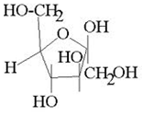

ii Does fructose conform to the general formula of a carbohydrate?
Molecular formula C₁₂H₂₂O₁₁, so yes it does
iii What other piece of information would you need to have before deciding if fructose was classified as a
carbohydrate?
The open chain form must be a polyhydroxy ketone or a polyhydroxy aldehyde (6 marks)

TOTAL MARK = 38

