Stage 2 Chemistry
Monitoring the Environment: Volumetric Analysis

Science Understanding
- Chromatography techniques, including thin layer chromatography (TLC), gas chromatography (GC), high-performance liquid chromatography (HPLC), and ion chromatography (IC), involve the use of a stationary phase and a mobile phase to separate the components of a mixture.
- The rate of movement of the components is caused by the differences between the strengths of the interactions between atoms, molecules, or ions in the mobile and stationary phases.
- Predict the relative rates of movement of components along a stationary phase on the basis of their polarities and charge, given the structural formulae or relative polarities of the two phases.
- Data from chromatography techniques can be used to determine the composition and purity of substances.
- Calculate and apply RF values and retention times in the identification of components in a mixture.
- Ion chromatography (also known as ion exchange chromatography) is used to remove either cations or anions from a mixture by replacing them with ions of another type.
- Explain, using equilibrium principles, how ions attached to the surface of a resin can be exchanged with ions in aqueous solution.

Adsorption Chromatography
Adsorption chromatography involves the use of a stationary phase and a mobile phase to separate the components of a mixture.
The strength of attraction between two substances depends on their relative polarities. Polar substances will attract polar substances and non-polar substances attract non-polar substances
The rate of movement of any component of a mixture depends upon how strongly it is adsorbed to the stationary phase and its solubility in the mobile phase, ie how strongly it is attracted to the mobile phase.
The movement of the component will depend on the polarity of the component and the polarities of the two phases.
The more polar substance will more strongly adsorb to the more polar phase
If a component is more attracted to the stationary phase it will: _____________________________
_____________________________
If a component is more attracted to the mobile phase it will: _____________________________
_____________________________

Paper and Thin Layer Chromatography
Paper chromatography consists of a strip of paper placed so that one end is in a solvent, usually water, so that the water absorbs up the paper, taking some of the solute with it.
Thin layer chromatography is run similarly, but uses a finely divided absorbent material such as silica on an aluminium or glass base.

Rf values
As the actual distance the solvent and solute travels depends on the size of the stationary phase and the time the solvent is left, there needs to be a way to compare different chromatograms. The retardation factor (Rf) is the ratio of how far the solute travelled compared to the solvent.
$$Rf=\frac{distance moved by solute}{distance moved by solvent}$$

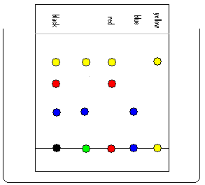
- A piece of chromatography paper is spotted with five different coloured inks. The paper is placed in a tall beaker, at the bottom of which is a small volume of a mixture of ethanol and butanol, able to act as a solvent for these inks.

After a certain period of time, the paper was removed and, on drying, spots of colour were seen, as indicated by the chromatogram above.
- State what would be classified as the stationary phase in this experiment.
___________________________________________________________________________
- State the solvent that was used for the mobile phase. ______________________________
- Which of the inks contained only one coloured component? ________________________
- How many components make up the black ink? ____________________
- Suggest the likely colour of the ink used in position 2. _____________________
- The blue and the yellow inks contain only one component. Which of these inks contains the component most strongly adsorbed to the stationary phase?
____________________________________
- Suppose the solvent front travelled 7.5 cm, and the component in the red ink moved 5.2 cm from the origin line, calculate the R_{f} factor for the component in the red ink.

- Suppose the blue ink with a known R_{f} value of 0.35, travels 2.63cm from the origin. Calculate the distance from the solvent front to the origin, in cm.

- Why are R_{f} factors always less than one?

- A thin layer chromatography experiment was performed to determine whether two different inks contained the same dyes. To do this, two chromatograms were obtained under identical conditions. A mixture of ammonia and ethanol was used as the more polar mobile phase.
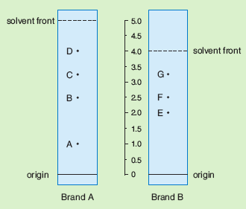

- In the Brand A ink, which component was most strongly adsorbed? ____________________
- In the Brand A ink, which component would be the least polar? _______________________
- Explain how the chromatogram for Brand B ink indicates that component G is more polar then component E.
______________________________________________________________________________
______________________________________________________________________________
______________________________________________________________________________
______________________________________________________________________________
______________________________________________________________________________
- Calculate the R _{f} values of component B and component E.

- What do you notice? _____________________________________________________

- What conclusion can be made about the composition of the two brands of ink in terms of components B and E?
______________________________________________________________________________
Gas and Liquid Chromatography
Gas and liquid chromatography work similarly, but instead of measuring the distance the sample moves up the stationary phase, we measure the time it takes to move through a long narrow tube of the stationary phase. Instead of Rf, we use the term retention time, which indicates how long the sample took to move through the column.

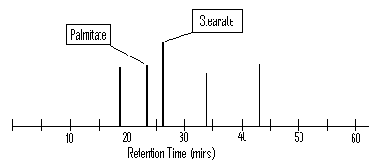
- A sample of artist’s paint used in the 17th century, was analysed by chromatography, using a non-polar solvent on a polar stationary phase. The chromatogram below shows the retention time for the components in the paint:

- If this method can determine “what is present” is this quantitative or qualitative analysis?
_____________________________________________________________
- Determine the retention time of Palmitate in minutes. Give your answer to two significant figures.

- Determine the retention time of Stearate in minutes. Give your answer to two significant figures.

- State which component, Palmitate or Stearate, moved more slowly through the chromatography column.
_________________________________________________________________________
- State and explain which component, Palmitate or Stearate, is more polar.
___________________________________________________________________________
___________________________________________________________________________
___________________________________________________________________________
___________________________________________________________________________
- A mixture of the four normal bases found in the DNA of mammals may be separated by liquid chromatography, using a polar solvent on a non-polar stationary phase.
Excessive ethanol in the body of humans can however lead to the production of an altered form of the base guanine. The presence of the altered base can be detected by chromatography.
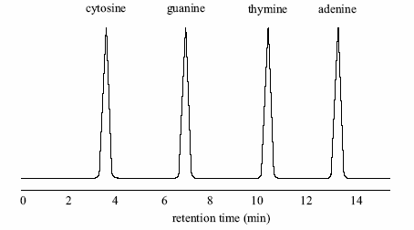
One chromatogram of a human, unaffected by ethanol, is shown in the diagram below:

- Explain how the chromatogram indicates that adenine is the most non-polar base.
___________________________________________________________________________
___________________________________________________________________________
___________________________________________________________________________
___________________________________________________________________________
___________________________________________________________________________

- State the evidence shown in the chromatogram that indicates that cytosine is the most polar base.
___________________________________________________________________________
___________________________________________________________________________
- Suppose a chromatogram was taken of a person who was extremely intoxicated with alcohol. This person would have their DNA base guanine altered by the presence of ethanol.
State how the presence of this altered form of guanine in a mixture of the DNA bases would change the appearance of the chromatogram.
___________________________________________________________________________
___________________________________________________________________________

