Stage 2 Chemistry
Organic and Biological Chemistry: Alcohols

Science Understanding
- Alcohols are classified as primary, secondary, or tertiary.
- Identify, name systematically, and draw structural formulae of alcohols containing:
  - up to eight carbon atoms in the main chain, with side chains limited to a maximum of two carbon atoms
  - one or more hydroxyl groups.
- Primary, secondary, and tertiary alcohols behave differently with oxidising agents.
- Describe how primary and secondary alcohols can be distinguished from tertiary alcohols by their reaction with acidified dichromate solution.
- Predict the structural formula(e) of the product(s) of dichromate oxidation of a primary or secondary alcohol, given its structural formula.

Primary Secondary and Tertiary Alcohols
In organic chemistry, the carbon bonded to the functional group is called the alpha carbon.
An alcohol is defined as primary, secondary or tertiary by the number of carbon bonds the alpha carbon has.
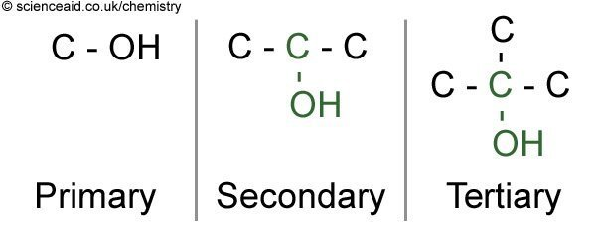

- Draw:
- 3-methyl butan-1-ol

- propan-2-ol

- 2,3-dimethyl-pentan-3-ol

- 2-methyl-pentan-2,4,5-triol

- Classify each hydroxyl group in question 1 as primary, secondary or tertiary.

Primary, secondary, and tertiary alcohols behave differently with oxidising agents.
Describe how primary and secondary alcohols can be distinguished from tertiary alcohols by their reaction with acidified dichromate solution.
Predict the structural formula(e) of the product(s) of dichromate oxidation of a primary or secondary alcohol, given its structural formula.
Alcohols can be oxidised by oxidising agents. The product of this oxidation depends on the type of alcohol being oxidised.
A common oxidising agent is acidified potassium dichromate. Dichromate ions reduce to chromium ions when they oxidise the alcohol. This process is accompanied by a colour change.
Dichromate ions __________________ colour _________________
Chromium ions ___________________ colour _________________
Write the half equation for the reduction of dichromate ions to chromium ions:

Describe why the solution must be acidified.

Oxidation of primary alcohols
When an alcohol is oxidised, it does not change position. As primary alcohols are always at the end of a carbon chain, so too will be their products.
The first oxidation product of a primary alcohol is an ________________________
Example: Propan-1-ol is oxidised to _______________________

Under the same oxidation conditions, the aldehyde can further oxidise to a ____________________

Oxidation of secondary alcohols
As a secondary alcohol is in the middle of a chain, so to will be the product.
Therefore the oxidation products of secondary alcohols are __________________________
Example: Pentan-2-ol is oxidised to ___________________________

No further oxidation can occur for secondary alcohols.

Oxidation of tertiary alcohols
Tertiary alcohols do not oxidise. The carbon attached to the alcohol already has three carbon-carbon bonds and cannot form any more bonds with oxygen.
Therefore the observation with potassium dichromate would be:

If we recognise that oxidation can be defined as a loss of hydrogen, it becomes clear why the reactions of alcohols proceed the way they do.

- Write the annotated equation showing the oxidation of 2-methyl-butan-1-ol using acidified potassium dichromate solution. Use structural formulae and name each product formed.

- Name the product formed if pentan-2-ol is oxidised. _____________________________
- State the colour change observed when an alcohol is oxidised using acidified potassium dichromate solution. ____________________________________________
- Why would no colour change be observed if 2-methyl-butan-2-ol was attempted to be oxidised using acidified dichromate solution
________________________________________________________________________
________________________________________________________________________

- Sketch the structural formula for 2,3-dimethyl -hexan-2-ol.

Is it primary, secondary or tertiary? ______________________________

- Sketch the structures of the following alcohols and classify them as primary, secondary or tertiary.
  - propan-2-ol

  - 2,3-dimethyl-hexan-3-ol

  - 3-ethyl-pentan-1-ol

  - 2,4-dimethyl-pentan-3-ol

- The structures of menthol and terpinol are shown below.
  - Label the hydroxyl groups as primary, secondary or tertiary
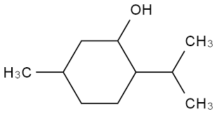
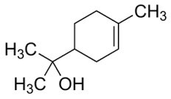
terpineol
menthol

  - Draw the structural formula of the product formed if menthol was oxidised with acidified potassium dichromate

  - Describe the observation made if terpineol was heated with a small amount of acidified dichromate solution.

  - Draw the structural formula of 2-methyl propanal.

  - Draw the structural formula and name the product formed if 2-methyl propanal is heated with acidified potassium dichromate solution.

  - To what homologous series does 2-methyl propanal belong? ___________________
  - 2-methyl propanal can be converted to 2-methyl propanol. Draw the structural formula of 2-methyl propanol.

  - What name is given to the reaction for the conversion of 2-methyl propanal to 2-methyl propanol? _______________________________________________

